Approaching Shannon’s Limit: KDPOF Evolves to KD

The new brand image more accurately represents the new challenges facing the company, including the opening of the new prototyping laboratory and assembly and test plant in Tres Cantos, Madrid.

Madrid (Spain) July 10, 2024 – KDPOF (leading supplier for high-speed connectivity over fiberoptics in harsh environments) proudly announces its business upgrade and brand-new corporate identity, evolving from ‘KDPOF – Knowledge Development for Plastic Optical Fiber’ to ‘KD – Approaching Shannon’s Limit’. As the company keeps striving for technical innovation and new products, the new image perfectly fits with the ambitious designs, challenges, and future projects.

“Since our founding in 2010, we’ve mastered the path of innovation, dedication, and excellence in high-speed optical network technology for harsh environments,” explained Carlos Pardo, CEO and Co-founder of KD. “The present major step is to evolve from a fabless company to setting up a high-volume production site for semiconductors close to our headquarter in Tres Cantos, Madrid, in Spain.”

Rubén Pérez-Aranda, CTO and Co-founder of KD, added: “With the development of our new IEEE Std 802.3cz compliant multi-gigabit optical transceivers, based on a new paradigm in integrating electronics, photonics, and optics, we’ve become a global benchmark for robust communication needs in the most adverse environments. Now it’s time for an upgrade of our corporate identity to align it with our achievements and future milestones.”

Last Thursday, July 4th, KDPOF successfully announced its rebranding and was honored to have the presence of great personalities such as the Minister for Industry and Tourism of the Government of Spain, Jordi Hereu, the Mayor of Tres Cantos, Jesús Moreno García, and investors who have supported the company from the beginning, such as Bullnet Capital, Caixa Capital Risk, Kibo Ventures, the high commissioner of PERTE CHIP, CDTI agents, and friends of the company.

Approaching Shannon’s Limit

When Carlos Pardo and Rubén Pérez-Aranda founded KDPOF in 2010, they entered new terrain as pioneers in the optical networking sector. Since then, the engineers have always kept exploring the limits of the impossible – striving for innovations nearing the Shannon limit. With their own production facility, KD empowers new paradigms of hybrid integration of microelectronics, photonics, and optics.

The Shannon limit or Shannon capacity of a communication channel refers to the maximum rate of error-free data that can theoretically be transferred over the channel if the link is subject to random data transmission errors, for a particular noise level. Stated by Claude Shannon in 1948, his theorem has wide-ranging applications in both communications and data storage.

Based on this principle and the values of teamwork, excellence, innovation, and passion, the company remains proud of its past achievements and ambitious about the challenges of the future that lie ahead. KD will continue to set milestones in the industry and in the history of high-speed optical communications for the automotive industry.

Optoelectronics Production in Spain

With the 26.8 million Euros IPCEI investment from the European Commission, KD is setting up a packaging plant for optoelectronic devices in Spain. “We’re excited to pioneer the manufacturing of automotive optoelectronics in Spain in high volume, thus reducing the dependency on Asia and US,” explained Carlos Pardo.

Close to its headquarters in Tres Cantos, KD is advancing a high-quality packaging factory for state-of-the-art optoelectronic devices. In addition, the company is opening their first prototype laboratory for testing their own products.

The new laboratory was inaugurated a few weeks ago and is equipped with highly qualified machinery for the necessary testing of KD products. During the day of the presentation of the new corporate identity, Jordi Hereu and Jesús Moreno García took a guided tour to learn about the quality processes that have been carried out in this new workspace for the past few weeks.

The encapsulation and testing factory for large volumes will go into operation in 2025. It will be applied for the first time to produce the upcoming transceiver IC for high-speed automotive optical communications, including the new and innovative optoelectronics packaging technology developed by KD.

Robust, Low Power, Scalable Automotive Network

Automotive is a very demanding industry. Incorporating AI, sensors, and processors in self-driving vehicles requires KD's technology to interconnect all components robustly and inexpensively using fiber optic links within the vehicle. The IEEE Std 802.3cz is therefore focusing on highly reliable conditions that enable lifetimes of 15 years and more, with low cost and high-volume implementations. The standard specifies speeds of 2.5, 5, 10, 25, and 50 Gb/s per lane. It meets automotive temperature requirements of -40 °C to +105 °C. The maximum link length is 40 meters with 4 inline connectors. The solution is affordable since the higher optical power budget allows lower tolerance connectors. Additionally, the OM3 fiber is widely used, ensuring high volume production.

An almost ideal communication channel allows a much simpler physical layer with a lower DSP/equalization complexity and no echo cancellation, resulting in lower power consumption, lower latency, a smaller silicon area, and an overall lower-cost solution. A specially dedicated Operations, Administration, and Maintenance (OAM) side channel is available for dependability and link management.

Words: 842

Keywords: kd, kdpof, Carlos Pardo, Rubén Pérez-Aranda, automotive, automotive Ethernet, fiberoptics, packaging plant, Tres Cantos, Madrid, Spain, PERTE, IPCEI, Jordi Hereu, Jesús Moreno García, Bullnet Capital, Caixa Bank, Kibo Ventures

More information:
New website: https://kd.tech
New corporate video: https://youtu.be/7OBDyfPPFZQ

Images:

Image 1: Approaching Shannon’s Limit: KDPOF evolves to KD

Copyright: KD
Download: https://ahlendorf-news.com/media/news/images/kd-logo-h.jpg
Image 2: Jordi Hereu, Minister of Industry, and Jesús Moreno García, Mayor of Tres Cantos, visited KD’s new lab for IC testing

Copyright: KD
Download: https://ahlendorf-news.com/media/news/images/240704-kd-presentation-1-h.jpg
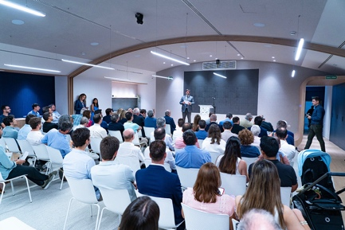 |  | Image 3: On July 4, 2024, KDPOF celebrated its transformation to KD with many industry partners, supporters, investors, and companions  Copyright: KD  Download: https://ahlendorf-news.com/media/news/images/240704-kd-presentation-2-h.jpg
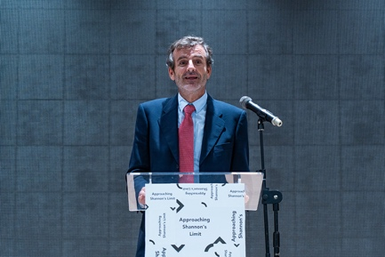 |  | Image 4: Carlos Pardo, CEO and Co-founder of KD, illustrates KD’s optoelectronics production in Spain  Copyright: KD  Download: https://ahlendorf-news.com/media/news/images/240704-kd-presentation-carlos-pardo-3-h.jpg
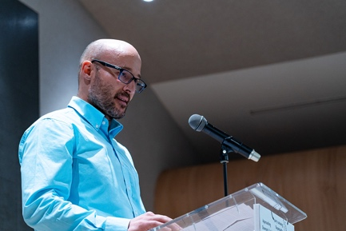 |  | Image 5: Rubén Pérez-Aranda, CTO and Co-founder of KD, presents the milestones of KD’s automotive Ethernet technology  Copyright: KD  Download: https://ahlendorf-news.com/media/news/images/240704-kd-presentation-4-ruben-perez-aranda-h.jpg
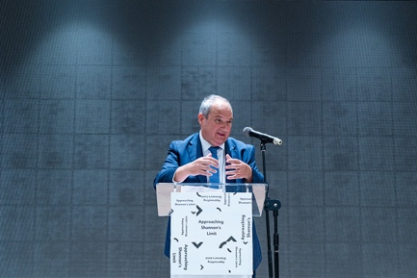 |  | Image 6: Jordi Hereu, Minister for Industry and Tourism of the Government of Spain, emphasizes the significance of KD’s chip production in Spain.  Copyright: KD  Download: https://ahlendorf-news.com/media/news/images/240704-kd-presentation-5-jordi-hereu-h.jpg

About KD

Fabless semiconductor supplier. KD provides innovative high-speed optical networking solutions for harsh environments. KD made gigabit communications for step-index plastic optical fiber (SI-POF) a reality for automotive. Founded in 2010 in Madrid, Spain, KD offers their cost-effective technology as fully qualified automotive-grade ASSP, integrating electronics, photonics, and optics in a single IC. KD’s technology makes use of information theory, innovative digital adaptive algorithms, and analog mixed-signal design to maximize the receiver’s sensitivity. KD makes innovation in optical coupling and packaging design, which enable integration of optical communications ports in electronic control units using standard printed circuit assembly processes. All together allows to support high-yield and reliable optoelectronics production in low-cost automotive-grade bulk CMOS deep submicron nodes, and delivering to carmakers low risk, low cost, and short time-to-market products. More information is available at www.kd.tech

MEDIA CONTACT
Mandy Ahlendorf
ahlendorf communication
- E-Mail: ma@ahlendorf-communication.com
- Phone: +49 89 41109402

https://en.wikipedia.org/wiki/Noisy-channel_coding_theorem

