Hinge Technology Integrates KD’s KD7251 in Automotive Camera System
Enabling 10 Gb/s Optical Camera Links over IEEE 802.3cz Fiber-optic Backbone in a Production-ready System
Madrid, Spain. June 9, 2026: Spanish semiconductor company KD announces the implementation of its KD7251 optical transceiver by Hinge Technology, a China-based leader in advanced vehicle electronics architecture, into a new automotive camera system for 10 Gb/s data transmission. This validates its applicability in real-world in-vehicle networks. The system leverages optical connectivity for high-resolution camera data links over a fiber-optic backbone, supporting zonal and centralized architectures. The KD7251 implements nGBASE-AU physical layers compliant with IEEE Std 802.3cz for multigigabit optical communication over multimode glass optical fiber. It supports high-speed sensor interconnection and backbone communication in software-defined vehicles (SDV).
Yang Jun, CTO of Hinge Technology, commented:
“At the Automotive Ethernet Congress in Munich, we presented our latest camera system in its first live public demonstration, featuring 10 Gb/s optical links based on KD’s KD7251. The system showcased lossless transmission of high-resolution video streams and real-time data exchange across a fiber-optic backbone. By combining multiple 10 Gb/s camera inputs and comparing them directly with 1 Gb/s links, we demonstrated clear advantages in image quality, latency, and overall system performance for next-generation automotive applications. This proves the readiness of optical multigigabit connectivity for in-vehicle deployment.”
Pablo Blazquéz, Business Development Manager for Europe at KD, stated:
“By integrating KD’s KD7251 into their ecosystem, Hinge Technology demonstrates a robust and future-ready optical architecture. Their solution supports both 1 Gb/s and 10 Gb/s camera connectivity, then aggregates the video streams through a 10 Gb/s optical backbone enabled by the KD7251. This showcases a scalable optical platform that can make a real difference not only in the Asian automotive market, but also in robotics, where reliable high-bandwidth connectivity is becoming increasingly critical.”

Multi-camera Architecture with 10 Gb/s Optical Data Transmission
The demonstrated system is based on a multi-camera architecture with optical links throughout the vehicle network. Two 10 Gb/s optical cameras are connected to each of two electronic control units (ECUs), with data transmitted over a fiber-optic backbone between the ECUs. One ECU aggregates and processes a total of four high-resolution video streams for functions such as image stitching and display output. In addition, a 1 Gb/s optical camera link is integrated for direct comparison between gigabit and multigigabit transmission.
KD7251 Enables Multigigabit Optical Links for In-vehicle Networks
At the core of the system, the KD7251 is a single-chip optoelectronic transceiver with an integrated optical interface, combining optical and electronic functionality in a compact device. It enables multigigabit data transmission over multimode glass optical fiber (OM3), supporting data rates up to 10 Gb/s as well as backward-compatible operation at lower speeds for flexible integration of different camera and sensor types. With low latency, robust EMC performance, and support for automotive requirements such as ASIL-B functional safety and extended temperature ranges, the KD7251 is designed for reliable high-speed connectivity in demanding in-vehicle environments. Its integrated bridging capabilities further support direct connection of camera sensors and processing units.

Words: 503
More information
Hinge Technology: https://www.hinge-tech.com/en/FiberOpticEthernet/index.aspx
KD7251 product page: https://www.kd.tech/products#category-multigiga
Keywords: KD, Hinge Technology, Pablo Blazquéz, Yang Jun, automotive, optical fiber, optical camera system, automotive industry, fiber optics, automotive Ethernet, in-vehicle network, BASE-AU, IEEE Std 802.3cz, KD7251

Images
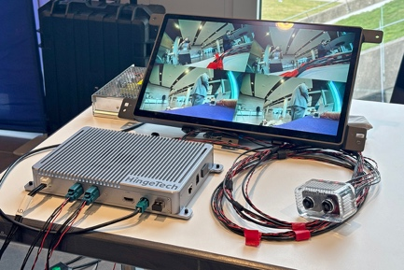 |  | Image 1: Demo of multi-camera system by Hinge Technology using KD’s KD7251 with 10 Gb/s optical links and fiber-optic backbone.  Copyright: KD  Download: https://ahlendorf-news.com/media/news/images/hinge-kd-camera-demo-1-h.jpg
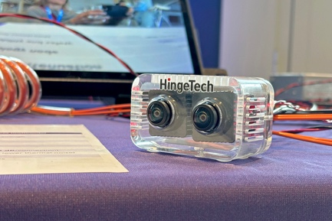 |  | Image 2: New optical automotive camera by Hinge Technology using KD’s KD7251 for 10 Gb/s data transmission over optical links.  Copyright: KD  Download: https://ahlendorf-news.com/media/news/images/hinge-kd-camera-demo-2-h.jpg
 |  | Image 3: Pablo Blazquéz is Business Development Manager for Europe at KD  Copyright: KD  Download: https://ahlendorf-news.com/media/news/images/kd-pablo-blazquez-1-h.jpg
 |  | Image 4: Yang Jun is CTO of Hinge Technology  Copyright: Hinge Technology  Download: https://ahlendorf-news.com/media/news/images/hinge-technology-yang-jun-h.jpg

About KD
Semiconductor supplier KD provides innovative high-speed optical networking solutions for harsh environments. Founded in 2010 in Madrid, Spain, KD offers its cost-effective technology as fully qualified automotive-grade ASSP, integrating electronics, photonics, and optics in a single IC. KD’s technology makes use of information theory, innovative digital adaptive algorithms, and analog mixed-signal design to maximize the receiver’s sensitivity. KD innovates in optical coupling and packaging design, which enables integration of optical communications ports in electronic control units using standard printed circuit assembly processes. Together, these offerings allow KD to support high-yield and reliable optoelectronics production in low-cost automotive-grade bulk CMOS deep submicron nodes, and to deliver products to carmakers with low risk, low cost, and short time-to-market products. KD made gigabit communications for step-index plastic optical fiber (SI-POF) a reality for automotive and is now developing its multi-gigabit optimized solution for use with Glass Optical Fiber (GOF) as well. More information is available at https://kd.tech
For media inquiries, please contact:
Mandy Ahlendorf, ahlendorf communication
E-Mail: ma@ahlendorf-communication.com
Phone: +49 89 41109402
About Hinge Automotive Technology
Hinge Automotive Technology Co., Ltd., was established in 2014 in Shanghai, China with a vision to driving continuous upgrades of EEA architecture for the global automotive industry. Since its creation, Hinge has pioneered the development of advanced automotive systems and products such as the self-adapting AUTOSAR system, in-vehicle TSN (time-sensitive networking) Ethernet, and optical Ethernet, essential technologies in crafting the electronic backbone for the smart vehicles of tomorrow. Powered by its R&D capability, Hinge has forged strategic partnerships with prominent entities (both upstream and downstream) across the automotive sector around the globe, including KD. Hinge has built a manufacturing and testing hub in Zhuji city, a facility encompassing 40 hectares with mass production capacity and delivery capability for OEMs.

Media Contact
Feng Li, Business Development Director
E-Mail: feng.li@hinge-tech.com
Phone: +971509392949 / +18615201397673

