KD and Hitachi High-Tech Enter Distribution Agreement

Strengthening Availability of Optical Multigigabit Solutions for Japan’s Automotive Ecosystem

Madrid, Spain, February 25, 2026: Semiconductor company KD proudly announced a distribution agreement with Hitachi High-Tech Corporation (“Hitachi High-Tech”). Under the agreement, Hitachi High-Tech will support market access and customer engagement for KD’s integrated optoelectronic devices in Japan, making it easier for automotive Tier-1s and suppliers to evaluate and adopt optical multigigabit connectivity solutions for next-generation vehicle architectures.

Takahiro Sugihara, Head of Industrial & Social Infrastructure Business from THE, commented on the agreement:
“KD is a pioneer in high-speed in-vehicle networking. This agreement aligns well with our commitment to providing cutting-edge technologies, products, and services that support the evolution of automotive electronics and advanced mobility, in line with our corporate vision of ‘Changing the World and Future with the Power of Knowledge.’”
Óscar Ciordia, Marketing and Sales Director of KD, emphasized the strategic importance of the cooperation:
“Japan is a highly advanced automotive market with strong technology leadership across OEMs and Tier-1 suppliers. We are honored to collaborate with Hitachi High-Tech as a business partner to better serve this market. This agreement represents an important milestone and a clear signal that optical multigigabit in-vehicle connectivity is gaining momentum in Japan. The collaboration is expected to accelerate adoption of optical networking across the Japanese automotive ecosystem.”

Focus on KD7251: Integrated Optoelectronics for Automotive Networks

As part of the collaboration, Hitachi High-Tech will support the introduction of KD’s KD7251, an integrated optoelectronics device designed for high-speed in-vehicle data transmission. Targeting demanding automotive environments, the device supports the transition toward scalable, future-proof network platforms for ADAS, infotainment, and emerging software-defined vehicle architectures.
The KD7251 combines optical and electronic functionality in a single device, enabling robust multigigabit links while helping automotive system designers address bandwidth growth, electromagnetic interference (EMI) constraints, and packaging efficiency in zonal and centralized vehicle architectures. The ASIC implements the BASE-AU physical layers and is compliant with the IEEE Std 802.3cz™ specification for automotive multigigabit optical communications links over multi-mode glass optical fiber (OM3).
Designed as a single-chip solution with an on-chip optical interface, the KD7251 supports data rates of 2.5, 5, and 10 Gb/s. It also includes bridging functionality to enable direct connectivity of MIPI-based sensors such as cameras and radar (CSI-2®), displays (DSI-2℠), as well as AI processors via PCIe®, simplifying system integration within the vehicle.

Words: 394

More information
KD7251: https://kd.tech/product/kd7251/
Keywords: KD, Hitachi High-Tech, Óscar Ciordia, Takahiro Sugihara, automotive, optical fiber, optical system, automotive industry, fiber optics, automotive Ethernet, in-vehicle network, BASE-AU, IEEE Std 802.3cz, KD7251

Images
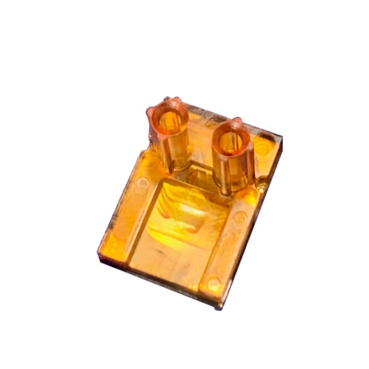 |  | Image 1: KD7251 single-chip device by KD for optical automotive multigigabit connectivity compliant with IEEE Std 802.3cz  Copyright: KD  Download: https://ahlendorf-news.com/media/news/images/kd-kd7251-optical-transceiver-1-h.jpg
 |  | Image 2: Takahiro Sugihara is Head of Industrial & Social Infrastructure Business from Hitachi High-Tech Europe  Copyright: Hitachi High-Tech  Download: https://ahlendorf-news.com/media/news/images/hitachi-takahiro-sugihara-1-h.jpg
 |  | Image 3: Óscar Ciordia is Marketing and Sales Director of KD  Copyright: KD  Download: https://ahlendorf-news.com/media/news/images/kd-oscar-ciordia-1-h.jpg

About KD
Semiconductor supplier KD provides innovative high-speed optical networking solutions for harsh environments. Founded in 2010 in Madrid, Spain, KD offers its cost-effective technology as fully qualified automotive-grade ASSP, integrating electronics, photonics, and optics in a single IC. KD’s technology makes use of information theory, innovative digital adaptive algorithms, and analog mixed-signal design to maximize the receiver’s sensitivity. KD innovates in optical coupling and packaging design, which enables integration of optical communications ports in electronic control units using standard printed circuit assembly processes. Together, these offerings allow KD to support high-yield and reliable optoelectronics production in low-cost automotive-grade bulk CMOS deep submicron nodes, and to deliver products to carmakers with low risk, low cost, and short time-to-market products. KD made gigabit communications for step-index plastic optical fiber (SI-POF) a reality for automotive and is now developing its multi-gigabit optimized solution for use with Glass Optical Fiber (GOF) as well. More information is available at https://kd.tech
For media inquiries, please contact:
Mandy Ahlendorf
ahlendorf communication
Email: ma@ahlendorf-communication.com
Phone: +49 89 41109402

About Hitachi High-Tech
Hitachi High-Tech provides cutting-edge technologies, products and services to society and customers with its corporate vision of "Changing the World and Future with the Power of Knowledge" to contribute to a sustainable global environment, healthy, safe and secure lives, and the sustained development of science and industry. We manufacture and sell clinical analyzers, biotechnology products and radiation therapy systems in the healthcare field, semiconductor manufacturing and inspection equipment in the semiconductor field, as well as analytical systems and electron microscopes used in environmental fields and materials research. We are also engaged in a wide range of business areas globally, providing high added-value solutions in battery, communication infrastructure, railway inspection, digital and other industrial and social infrastructure fields. We provide solutions through a deeper understanding of the issues facing society and our customers to contribute to realizing a sustainable society. The company's consolidated revenues for FY2024 were approx. JPY 756.5 billion. For further information, visit https://www.hitachi-hightech.com/global/en/

