FORTEC Integrated Unveils the SBCPRO-X51 Single Board Computer

New 3.5" SBC with Intel® Amston Lake Atom® x7211RE Processor for Demanding Industrial and IoT Applications

Germering (Germany) November 26, 2025 – The FORTEC Group – a leading provider of industrial display, embedded, system solutions, and power supplies – is presenting the new 3.5" Single Board Computer (SBC) SBCPRO-X51, featuring the Intel® Amston Lake Atom® x7211RE processor. The SBCPRO-X51 simplifies modern industrial computing and significantly expands the capabilities of a standard 3.5-inch SBC. Thanks to its flexible M.2 expansion modules, the SBC can be configured for a wide range of industrial applications.

The SBCPRO-X51 is engineered for demanding industrial and IoT environments. With its wide operating temperature range from –20°C to +85°C, fanless architecture, and guaranteed long-term availability, it delivers a dependable, high-performance platform for building future-ready embedded systems.

Embedded Technology with Long-Term Availability

"In the embedded industry, the lifecycle of many platforms is very short – new generations arrive quickly, and older ones often disappear just as fast," explains Stefan Zieboll, Product Manager Embedded at FORTEC Integrated. "The SBCPRO-X51 is deliberately designed differently: it is not a short-term trend product, but a robust base for industrial applications that need to run stably for many years. It is a reliable platform for developers, purchasers, and product managers who require planning certainty and depend on trustworthy hardware."

Flexible, Robust, and Versatile for Industrial Use

To support a wide range of application scenarios, FORTEC Integrated offers several M.2 expansion modules—including a USB-C M.2 module that enables display connectivity through a single USB-C cable. This single interface carries power, DisplayPort video, and touch functionality. For larger, high-resolution 4K displays, a dedicated V-by-One M.2 module is available. With broad compatibility from eDP to V-by-One, the SBCPRO-X51 can drive anything from compact TFT panels to large-format displays, ensuring seamless integration with diverse project requirements.

Additionally, classic industrial interfaces such as GPIO and serial COM ports are available without the need for extra adapters. For integration into IoT infrastructures, the SBCPRO-X51 features two 2.5 Gbit Ethernet ports and optional Wi-Fi.

Its rugged design is built for uninterrupted 24/7 operation in industrial environments, offering strong resistance to vibration, shock, and electromagnetic interference.

Control, Edge AI, and Image Processing

The SBCPRO-X51 is powered by an Intel® Amston Lake-N Atom® x7211RE CPU. This energy-efficient multi-core processor is well suited for control tasks, Edge AI workloads, and advanced image processing. With DDR5 memory support and three M.2 sockets-accommodating NVMe flash storage, Wi-Fi modules, or cellular connectivity, the platform delivers exceptional performance and outstanding configuration flexibility.

On the software side, the SBCPRO-X51 supports Windows 11 IoT LTSC, various Linux variants, and common embedded tools. Long-term support and software maintenance are integral to the concept, alongside the guaranteed long-term hardware availability. Alternatively, FORTEC Integrated also offers the BPCPRO-X51 as a fully integrated Box PC solution.

Words: 468

Keywords: FORTEC Integrated, FORTEC Group, BPCPRO-X51, Single Board Computer, Intel Atom, Amston Lake, Edge AI, Industrial Automation, HMI, Industrial Signage, Industrial IoT, Industrial PC, Embedded Computing

Further Information:
https://www.fortec-integrated.de/en/products/embedded/single-board-computer/detail/fortec-integrated/sbcpro-x51/

Images:

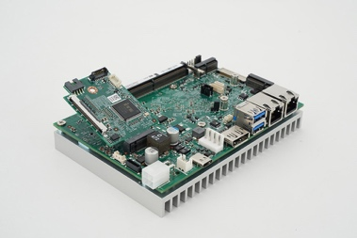 | Image 1: SBCPRO-X51 from FORTEC: flexible 3.5" SBC with Intel® Amston Lake for demanding projects  Image source/Copyright: FORTEC Integrated  Download: https://www.ahlendorf-news.com/media/news/images/fortec-integrated-sbcpro-x51-intel-amston-lake-h.jpg
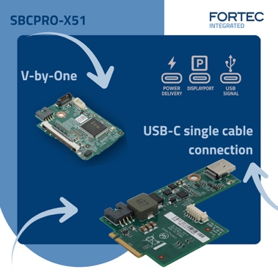 | Image 2: SBCPRO-X51 with flexible M.2 modules for V-by-One and USB-C for power, DisplayPort, and touch  Image source/Copyright: FORTEC Integrated  Download: https://www.ahlendorf-news.com/media/news/images/fortec-integrated-sbcpro-x51-vbyone-usbc-h.jpg
 | Image 3: Stefan Zieboll is Product Manager Embedded at FORTEC Integrated  Image source/Copyright: FORTEC Integrated  Download: https://www.ahlendorf-news.com/media/news/images/fortec-integrated-stefan-zieboll-h.jpg

About FORTEC Integrated

FORTEC Integrated (formerly Distec) is part of the FORTEC Group, a globally active and recognized specialist in display technology and embedded computing for projects across all industries. Headquartered in Germering near Munich, with a production facility in Hörselberg-Hainich near Eisenach, the company develops, manufactures, and markets innovative solutions along with a broad portfolio of components, TFT displays, embedded boards, systems, and services.
Its innovative solutions—ranging from assemblies and kits to full OEM end products—are built on hardware and software developed in FORTEC Integrated’s in-house design center in Germering. In addition to customer-specific developments and modifications, the service offering includes product enhancements such as VacuBond® Optical Bonding, monitor system assembly, and complete product manufacturing. A wide selection of touchscreens and the company’s dedicated Touch Competence Center enable tailored touch solutions, even for demanding environmental conditions. FORTEC Integrated also benefits from the products, services, and expertise of the extensive FORTEC high-tech corporate network. More information is available at https://www.fortec-integrated.de/

FORTEC Integrated Products are available from:
Europe: FORTEC Integrated GmbH, Germering – https://www.fortec-integrated.de/
UK & Benelux: FORTEC Technology UK, Huntingdon – https://www.fortec.uk/
North America: FORTEC US Corp., Ronkonkoma NY – https://www.fortec.us/

Power Supplies are Available From:
FORTEC Power GmbH, Riedstadt, https://www.fortec-power.de/
FORTEC Switzerland AG, Würenlos, https://www.fortec.ch/

FORTEC Integrated GmbH
Augsburger Straße 2b
82110 Germering
Germany
T +49 89 894363 0
F +49 89 894363 131
E sales|at|fortec-integrated.de
W https://www.fortec-integrated.de

A company of FORTEC Group

Media Contact
Mandy Ahlendorf
ahlendorf communication
T +49 89 41109402
E ma@ahlendorf-communication.com

