Aukua Unveils the MGA8410 Advanced Ethernet & IP Test Platform
Aukua expands its portfolio with a next-generation platform offering higher port density, industry unique 3-in-1 capabilities, and enhanced Automotive Ethernet testing features.
Austin, Texas – October 13, 2025 – Aukua Systems, Inc. (https://www.aukua.com), a leading provider of Ethernet and IP network testing and monitoring solutions, today introduced the MGA8410 (https://www.aukua.com/products/mga8410.html), its next-generation Ethernet & IP test platform designed for Automotive Ethernet network testing.
The MGA8410 builds on the award-winning MGA2510, adding more ports and expanded functionality in a compact, 1U-high, SFP-based form factor. The increased port density and advanced FPGA-based architecture deliver the highest levels of precision and performance required for testing of Automotive Ethernet ECUs, PHYs, and Switch semiconductors, while continuing to deliver Aukua’s nanosecond timestamp precision and line-rate performance.

3-in-1 Testing for Enhanced Efficiency and Versatile Application
Aukua’s platforms stand out for their unique 3-in-1 capability, combining a Traffic Generator/Analyzer, Network Impairment Emulator, and Inline Packet Capture and Analyzer in a single device. This integrated approach eliminates the need for multiple tools, reduces setup complexity, expands use-case coverage, and significantly lowers overall test costs. By consolidating functionality without compromising accuracy or repeatability, the MGA8410 enables engineering teams to accelerate test validation cycles while making the most of their budgets.

Simultaneous Test Operations with Broad Interface Support
The MGA8410 also introduces a breakthrough feature: the ability to simultaneously perform traffic generation and inline packet capture or network impairment emulation. This means engineers can use the Traffic Generator/Analyzer to test devices under specific conditions, such as jamming, throughput validation, and latency or jitter measurement while simultaneously capturing and analyzing live data streams without interruption.
Ensuring comprehensive coverage, the MGA8410 supports BASE-T, BASE-T1, BASE-R, BASE-X and BASE-RH interfaces for all rates from 10 Mbps to 10 Gbps, including the new multigigabit Automotive BASE-T1 standards for 2.5G/5G/10GBASE-T1 (IEEE 802.3ch).

Empowering Automotive Ethernet Validation with Precision and Scale
“The MGA8410 represents a major step forward for our customers developing next-generation in-vehicle networking technologies,” said Sudarshan Rajagopal, Co-Founder and Vice President of Aukua Systems. “By combining higher port density with our proven generation, impairment, capture, and monitoring capabilities in a cost-effective, 3-in-1 platform, engineers can now execute rigorous, complex, and reproducible validation with unmatched accuracy and efficiency.”
The platform helps automotive OEMs, Tier-1 suppliers, and semiconductor vendors test and validate Ethernet and IP-based designs more effectively by providing precise and repeatable real-world testing in a single, compact solution that simplifies validation and accelerates innovation. Its enhanced capabilities make it an indispensable solution for building the robust, high-performance networks required in current and future vehicles.

Aukua is showcasing the MGA8410 this week at the 2025 IEEE SA Ethernet & IP @ Automotive Technology Day (E&IP@ATD) in Toulouse, France.

Words: 451
Keywords: Aukua Systems, MGA8410, automotive Ethernet, automotive testing, Sudarshan Rajagopal, in-vehicle network, Ethernet validation, network test platform, traffic generator, BASE-T1
More information: https://www.aukua.com/products/mga8410.html

Images

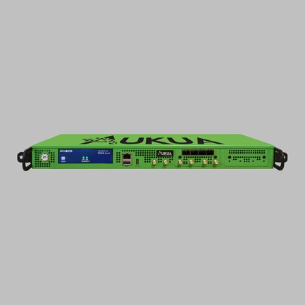 |  | Image 1: Aukua Systems presents MGA8410 advanced automotive Ethernet & IP test platform  Copyright: Aukua Systems  Download: https://www.ahlendorf-news.com/media/news/images/aukua-systems-mga8410-ethernet-ip-test-h.jpg
 |  | Image 2: Sudarshan Rajagopal is Co-Founder and Vice President of Aukua Systems  Copyright: Aukua Systems  Download: https://www.ahlendorf-news.com/media/news/images/aukua-systems-suds-rajagopal-vp-h.jpg

About Aukua Systems
Aukua Systems Inc. is a Texas, US-based provider of precision Ethernet testing and visibility solutions. Whether developing, validating, deploying, supporting or managing applications or networks, our solutions help improve performance and make networks more secure. The Aukua product line includes packet capture tools, analyzers, traffic generators, and network impairment emulators. Since 2015, equipment manufacturers, semiconductor companies, automotive OEMs and Tier1's, large enterprises, service providers, and government agencies worldwide have depended on Aukua to build stronger and more secure applications and networks. More at https://aukua.com.

For latest updates, please follow Aukua Systems:
https://www.linkedin.com/company/aukua/

Aukua Systems Inc.
9430 Research Blvd. Ste IV305,
Austin, Texas 78759, U.S.A.
E sales@aukua.com
T +1 866 533-2215

Media Contact Europe:
Mandy Ahlendorf
E ma@ahlendorf-communication.com
T +49 89 41109402

