ARIES Embedded Unveils OSM-compliant MSRZG3E System-in-Package

New Embedded Module with Renesas’ Latest RZ/G3E MPU Powers Advanced HMI in Industrial and Medical Applications

Fuerstenfeldbruck (Germany) 17 September 2025 – ARIES Embedded, specialist in embedded services and products, introduces the MSRZG3E, a new OSM-compliant system-in-package (SiP) built on the Renesas RZ/G3E Microprocessor (MPU) . Powered by the RZ/G3E, which integrates a quad-core Arm® Cortex®-A55, a Cortex-M33 real-time core, and the Ethos™-U55 neural processing unit (NPU) in a single chip solution, the MSRZG3E delivers a powerful platform for advanced multimedia and AI workloads. “With the RZ/G3E at its core, this SiP merges high-efficiency compute performance with a rich set of industrial interfaces optimized for demanding HMI applications,” stated Andreas Widder, Managing Director of ARIES Embedded. Packaged in the compact OSM (Open Standard Modules by SGET e. V.) size M form factor (30×45 mm²) with 476 contact pads, the module exposes nearly the entire CPU features, enabling seamless integration into industrial, medical, and edge computing systems.

Ivo Marocco, Vice President of Solutions of Renesas, added: “We greatly value our collaboration with ARIES Embedded as part of Renesas’ partner ecosystem. Their new MSRZG3E module, based on our recently launched RZ/G3E MPU, brings an innovative, high-value solution to our ecosystem—enabling faster development cycles and flexible customization for a wide range of embedded applications.”

Enhanced Processing and High-Speed Interfaces for Demanding Edge Applications

The MSRZG3E module from ARIES Embedded is engineered to power edge computing systems with robust multimedia capabilities and high-performance processing. The RZ/G3E MPU integrates a quad Arm Cortex-A55 main CPU running up to 1.8 GHz for Linux-based tasks, a Cortex-M33 sub-CPU at up to 200 MHz for NPU, and an Arm Ethos-U55 NPU delivering up to 512 GOPS (256 MACs) for AI acceleration. High-speed connectivity includes a PCIe Gen3 (2-lane) interface, USB 3.2 Gen2x1 host, and dual Gigabit Ethernet ports. Additional versatile interfaces—USB 2.0 Host/OTG, CAN FD, UART, I2C, SPI, and ADC—offer flexible integration for a wide range of industrial and embedded use cases.

Rich Multimedia Support for Advanced HMI Uses

To meet the demands of high-end human-machine interfaces, the MSRZG3E system-in-package integrates robust multimedia functionality. It supports dual display outputs via RGB and MIPI-DSI, along with MIPI-CSI camera inputs using 1, 2, or 4 data lanes. The module also features an integrated video codec engine for H.264/H.265 encoding and decoding, a frame data processor, video signal processor, image scaler, rotation engine, color space converter, and color keying for dynamic rendering and display control.

Scalable Memory and Industrial-grade Reliability

The MSRZG3E is available with LPDDR4 RAM configurations from 512 MB up to 8 GB and eMMC NAND Flash storage ranging from 4 GB to 64 GB. Designed for durability, it supports both commercial (-25 °C to +70 °C) and industrial-grade (-40 °C to +85 °C) operating temperatures, ensuring reliable performance across a wide range of embedded environments.

Fast Development with MSRZG3EEVK Evaluation Platform

To streamline CPU project development, ARIES Embedded offers the MSRZG3EEVK evaluation board. It is an ideal platform for both rapid prototyping and early-stage system integration. Featuring the MSRZG3E module based on Renesas’ RZ/G3E MPU, the board delivers high-performance processing for real-time control. With its compact form factor, broad interface support, and optimized design for low power consumption and thermal efficiency, the MSRZG3EEVK offers a cost-effective foundation for building and testing next-generation embedded applications.

The MSRZG3E SiP will be available Q3/2025.

Words: 561

More information

MSRZG3E: https://www.aries-embedded.com/system-on-module/cpu/rzg3e-renesas-cortexa55quadcore-msrzg3e-osm-ethernet-pcie-npu
Evaluation kit: https://www.aries-embedded.com/evaluation-kit/cpu/rzg3e-renesas-cortexa55quadcore-msrzg3e-osm-ethernet-pcie-npu
Renesas RZ/G3E Microprocessor (MPU): https://www.renesas.com/rzg3e

Keywords: Aries Embedded, Andreas Widder, MSRZG3E, MSRZG3EEVK, embedded system, HMI, multimedia, medtech, AI, artificial intelligence, industrial, Renesas, system-in-package, OSM, SGET, RZ/G3E
Images

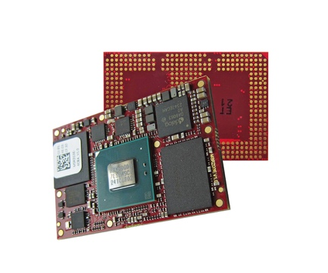 | Image 1: ARIES Embedded presents OSM-compliant MSRZG3E system-in-package featuring Renesas RZ/G3E MPU  Copyright: ARIES Embedded GmbH  Download: https://www.ahlendorf-news.com/media/news/images/aries-embedded-msrzg3e-renesas-1-h.jpg
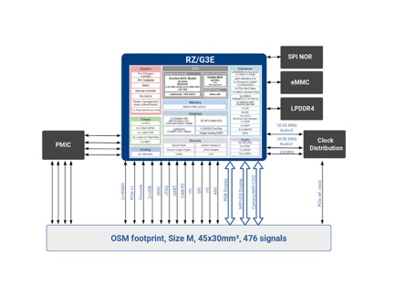 | Image 2: Block diagram of the OSM-compliant MSRZG3E SiP by ARIES Embedded based on Renesas RZ/G3E MPU  Copyright: ARIES Embedded GmbH  Download: https://www.ahlendorf-news.com/media/news/images/aries-embedded-msrzg3e-renesas-blockdiagram-1-h.jpg
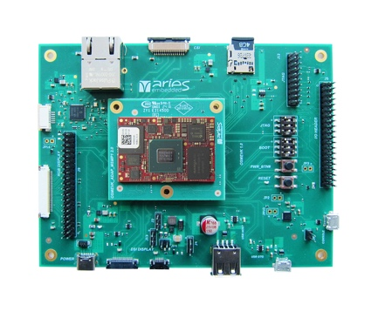 | Image 3: MSRZG3EEVK evaluation board by ARIES Embedded with Renesas RZ/G3E MPU for rapid prototyping and quick project entry  Copyright: ARIES Embedded GmbH  Download: https://www.ahlendorf-news.com/media/news/images/aries-embedded-msrzg3eevk-renesas-1-h.jpg
 | Image 4: Andreas Widder is Managing Director of ARIES Embedded GmbH  Copyright: ARIES Embedded GmbH  Download: http://www.ahlendorf-news.com/media/news/images/aries-embedded-Andreas-Widder-H.jpg

About ARIES Embedded

ARIES Embedded provides hardware and software development and standard products for industrial and agricultural sectors. The 2001 founded embedded specialist headquartered in Fuerstenfeldbruck, Germany, focuses on FPGA technology and open-source software. The portfolio comprises of modular systems for flexible and fast use in functional prototypes, pilot series and mass production. On customer request, ARIES Embedded individually customizes standard products in accordance with project requirements. Further information is available at www.aries-embedded.com.

ARIES Embedded GmbH
Schöngeisinger Str. 84
DE-82256 Fürstenfeldbruck
Fon: +49 8141 36 367 0
Fax: +49 8141 36 367 67
www.aries-embedded.com
info@aries-embedded.de

Media Contact
Mandy Ahlendorf
ahlendorf communication
ma@ahlendorf-communication.com
+49 89 41109402

