KD Partners with Keysight to Advance Multigigabit Optical Automotive Ethernet Testing

Madrid, Spain. January 28th, 2025: KD, a fabless semiconductor company, is pleased to announce a landmark agreement with Keysight Technologies to partner on optical parameters measurement including TDFOM based on the IEEE Std 802.3cz physical layer test standard.

The Transmitter Distortion Figure of Merit (TDFOM) is a key metric for assessing the quality of multigigabit optical signals transmitted over glass optical fiber. As defined in the IEEE Std 802.3cz, TDFOM is measured after a reference receiver, which emulates a representative integrated circuit (IC) implementation and ensures the interoperability of transmitters in terms of signal integrity, valid to be received by a compliant receiver. Furthermore, TDFOM is critical for calibrating reference transmitters, enabling precise compliance assessment of optical receivers.

The TDFOM measures the transmitted optical signal ability to meet the required system Bit Error Rate (BER) after passing through a worst-case optical channel and a reference receiver, evaluated using an optical-to-electrical converter (O/E) and an oscilloscope. Keysight and KD have been in close collaboration during the development of the IEEE 802.3cz standard to create the final version of the TDFOM. KD has developed a software-based reference receiver and signal metric analysis, aligned with the IEEE Std 802.3cz specifications.
“With this agreement, we make a big step in providing to OEMs and Tier-1 companies with the necessary means to test the quality of developments that incorporate optical communications according to the IEEE Std 802.3cz. Keysight and KD have collaborated in IEEE 802.3 to define the tests and metrics that ensure the new Ethernet communications standard meets the quality requirements demanded by the automotive industry," stated Rubén Pérez-Aranda, KD’s CTO and co-founder.

This partnership underscores KD’s and Keysight's commitment to supporting technological innovation in the automotive sector, driving advancements in optical communication systems, and ensuring the highest standards of quality and performance.

Thomas Goetzl, Vice President and General Manager of Keysight's Automotive & Energy Solution highlighted the importance of this agreement:
“Automotive Ethernet technologies have evolved and now derive significant benefits from optical fiber technologies for enabling multigigabit in-vehicle networking. Keysight is pleased to collaborate with KD, a leading supplier of optical transceivers for the automotive industry, to enhance our support for customers in this emerging ecosystem. Keysight’s market-leading test and measurement equipment, combined with KD’s expertise in optical measurements, aims to assist customers in exploring reliable high-speed links in in-vehicle networking.”

The collaboration between KD and Keysight is intended to support the automotive industry with advanced testing tools for optical communication systems. Combining KD's expertise in new technology development with Keysight’s test equipment, this partnership aims to assist OEMs and Tier-1 companies validate and optimize next-generation technologies. This alliance drives innovation, enhances interoperability, and encourages the adoption of advanced optical communication standards across the automotive sector.

Words: 465

----

Keywords: TDFOM, IEEE Std 802.3cz, technology, software, automotive, robust solution, optical fiber, optical system, automotive industry, Keysight, KD, fiber optic, automotive Ethernet, automotive test, in-vehicle network

Images

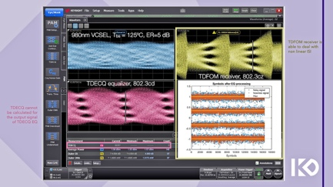 |  | Image 1: Comparison of TDECQ equalizer performance vs TDFOM receiver performance, both doing processing of VCSEL signal operating at TBS = 125 ºC, 26.88 GBd, PAM4  Copyright: KD/Keysight  Download: https://ahlendorf-news.com/media/news/images/kd-keysight-comparison-tdecq-vs-tdfom-h.jpg
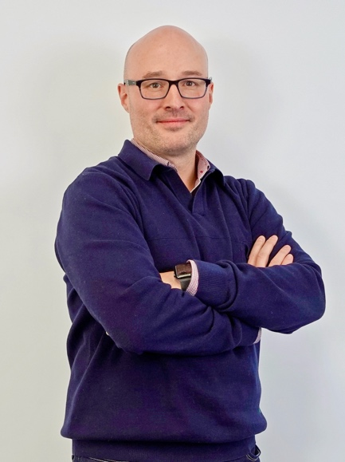 |  | Image 2: Rubén Pérez-Aranda is CTO and Co-founder of KD  Copyright: KD  Download: https://ahlendorf-news.com/media/news/images/kd-ruben-perez-aranda-cto-co-founder-1-h.jpg
 |  | Image 3: Thomas Goetzl is Vice President and General Manager of Keysight's Automotive & Energy Solution  Copyright: Keysight  Download: https://ahlendorf-news.com/media/news/images/keysight-thomas-goetzl-vp-1-h.jpg

About KD
Fabless semiconductor supplier, KD provides innovative high-speed optical networking solutions for harsh environments. Founded in 2010 in Madrid, Spain, KD offers its cost-effective technology as fully qualified automotive-grade ASSP, integrating electronics, photonics, and optics in a single IC. KD’s technology makes use of information theory, innovative digital adaptive algorithms, and analog mixed-signal design to maximize the receiver’s sensitivity. KD innovates in optical coupling and packaging design, which enables integration of optical communications ports in electronic control units using standard printed circuit assembly processes. Together, these offerings allow KD to support high-yield and reliable optoelectronics production in low-cost automotive-grade bulk CMOS deep submicron nodes, and to deliver products to carmakers with low risk, low cost, and short time-to-market products. KD made gigabit communications for step-index plastic optical fiber (SI-POF) a reality for automotive and is now developing its multi-gigabit optimized solution for use with Glass Optical Fiber (GOF) as well. More information is available at www.kd.tech

About Keysight
At Keysight (NYSE: KEYS), we inspire and empower innovators to bring world-changing technologies to life. As an S&P 500 company, we’re delivering market-leading design, emulation, and test solutions to help engineers develop and deploy faster, with less risk, throughout the entire product life cycle. We’re a global innovation partner enabling customers in communications, industrial automation, aerospace and defense, automotive, semiconductor, and general electronics markets to accelerate innovation to connect and secure the world. Learn more at Keysight Newsroom and www.keysight.com.

For media inquiries, please contact:
KD: Mandy Ahlendorf
ahlendorf communication
- E-Mail: ma@ahlendorf-communication.com
- Phone: +49 89 41109402

