FORTEC Integrated Introduces New PE8000G from ASUS IoT

High-Performance Edge-AI GPU Computer for Demanding AI Applications in Extreme Environments

Germering (Germany) 11 December 2024—FORTEC Integrated, a leading German specialist in industrial TFT flat-panel displays, embedded products, and system solutions, presents the new PE8000G from ASUS IoT. This state-of-the-art Edge-AI GPU computer has been designed for use in harsh industrial environments. With its robust construction and exceptional computing power, the PE8000G enables real-time AI inferences directly at the network edge. “It supports up to two 450-watt GPU cards as well as the latest Intel® Core™ processors from the 14th, 13th, and 12th generations,” explained Thomas Schrefel, Product Manager Embedded at FORTEC Integrated. “This makes it ideal for data-intensive, AI-driven applications.” Typical applications include medical technology, smart industrial systems, video surveillance, and transportation systems.

The PE8000G series includes several system variants, such as the PE6000G, PE5101D, PE5100D, and PE4000G, catering to different performance and configuration requirements.

Maximum Performance for Complex AI Tasks: Dual-GPU Support

The PE8000G is designed to handle the most demanding AI tasks. With the ability to support two high-performance GPU cards, each with up to 450 watts, the system is perfectly suited for neural networks, advanced image processing, and real-time AI inferences. Tasks can be intelligently distributed across GPUs and processed in real time, ensuring maximum performance, stability, and precision. Additionally, the PE8000G ensures future-proof applications by meeting the ever-growing demands for computing power. Combined with powerful Intel® Core™ processors and up to 64 GB of DDR5-SDRAM, this Edge-AI computer is an ideal platform for extremely data-intensive computations.
Rugged and Versatile for the Harshest Conditions

The PE8000G is engineered for extreme environments and complies with the MIL-STD-810H military standard. It is capable of operating within a wide temperature range of -20 °C to 60 °C and is resistant to strong vibrations and shocks.

The box PC also features an 8–48V wide-range DC input as well as an integrated ignition control and power monitoring functions. Four hot-swappable 2.5-inch SSD slots enable uninterrupted data availability and fast storage expansion – crucial for scenarios requiring high reliability.

In addition to Intel-based architectures, ASUS IoT offers NVIDIA-based solutions specifically designed for Edge-AI applications. These systems combine ARM-based CPUs with NVIDIA® GPUs, delivering exceptional energy efficiency and performance ranging from 20 to 275 TOPS/Watt. The Jetson series is robust and versatile, supporting a wide array of applications, from real-time analytics to complex image processing.

With these innovative technologies, FORTEC Integrated and ASUS IoT are setting new benchmarks in precision, speed, and reliability for industrial AI applications. The broad portfolio of Edge-AI solutions provides a future-proof foundation for demanding projects across various industries.

Words: 439

More information: https://www.fortec-integrated.de/en/products/embedded/embedded-systems/detail/asus-iot/pe8000g/

Keywords: FORTEC Integrated, Distec, PE8000G, Asus IoT, Thomas Schrefel, Edge-AI, embedded, Box PC, SBC, AI, artificial intelligence, medical technology, image analysis, smart industrial systems, video surveillance, transportation
Images

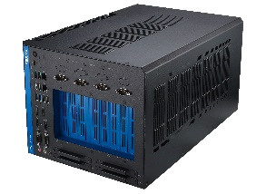 | Image 1: FORTEC Integrated presents powerful PE8000G from ASUS IoT for demanding AI applications  Copyright: ASUS  Download: https://www.ahlendorf-news.com/media/news/images/fortec-integrated-pe8000g-asus-iot-h.jpg
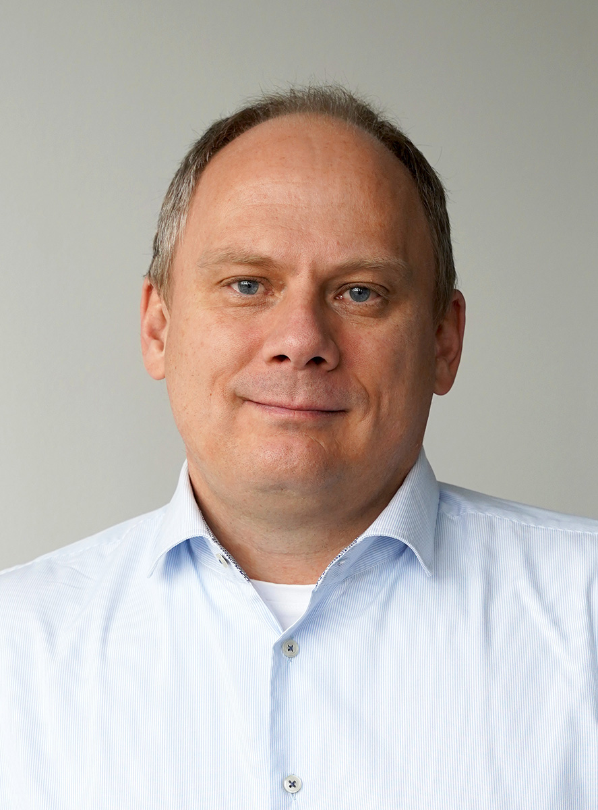 | Image 2: Thomas Schrefel is Product Manager Embedded at FORTEC Integrated  Copyright: FORTEC Integrated  Download: https://www.ahlendorf-news.com/media/news/images/fortec-integrated-thomas-schrefel-h.jpg

About FORTEC Integrated

FORTEC Integrated (formerly Distec) is a FORTEC Group company, a globally active and recognized specialist in the field of display technology and embedded computing for projects from all industries. The company, headquartered in Germering near Munich and with a factory in Hörselberg-Hainich near Eisenach, develops, manufactures, and markets innovative solutions and a wide range of components, TFT displays, embedded boards, systems, and services. The innovative solutions from assemblies and kits to OEM end products are based on hardware and software developed by FORTEC Integrated / Distec in its own design center in Germering. FORTEC Integrated's range of services includes customer-specific developments and adaptations, product refinements such as VacuBond® optical bonding and the assembly of monitor systems, as well as the manufacture of finished products. A wide range of touch screens and the internal touch competence center enable individual touch solutions even for difficult environmental conditions. In addition, FORTEC Integrated can draw on the goods, services, and know-how of the extensive FORTEC high-tech company network. Further information can be found at https://www.fortec-integrated.de/en/

The products of FORTEC Integrated are available at:
Europe: FORTEC Integrated GmbH, Germering, https://www.fortec-integrated.de/en/
UK and Benelux: FORTEC Technology UK, Huntingdon, https://www.fortec.uk/
North America: FORTEC US Corp., Ronkonkoma NY, http://www.fortec.us/

Power Supplies are available at:
FORTEC Power GmbH, Riedstadt, https://www.fortec-power.de/
FORTEC Switzerland AG, Würenlos, https://www.fortec.ch/

FORTEC Integrated GmbH
Augsburger Straße 2b
82110 Germering
Germany
T +49 89 894363 0
F +49 89 894363 131
E info|at|fortec-integrated.de
W www.fortec-integrated.de

A FORTEC Group company

Press contact:
Mandy Ahlendorf
ahlendorf communication
T +49 89 41109402
E ma@ahlendorf-communication.com

