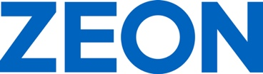

ZEON Europe GmbH
Hansaallee 249
40549 Düsseldorf
Germany
Phone +49-211-5267-0
Fax +49-211-5267-160
Email zeinfo@zeon.eu
Public Relations: Tatiana Kromhout

www.zeon.eu
P R E S S R E L E A S E

ZEON Increases Production Capacity for Zetpol® at US Plant

25 % Capacity Expansion of Hydrogenated Nitrile Rubber (HNBR) by 2025

Duesseldorf (Germany) July 2, 2024 – ZEON Europe GmbH – European subsidiary of ZEON Corporation, Japan, a leading and globally operating producer of specialty polymers – welcomes the increase of production capacity for Zetpol® Hydrogenated Nitrile Rubber (HNBR) at the US Plant in Pasadena, Texas. “The expansion will increase ZEON’s global HNBR rubber capacity by approximately 25 % and is expected to be completed by 2025,” stated Dr. Kai Kremer, Commercial Manager HNBR of ZEON Europe.

Zetpol® is a specialty rubber with enhanced heat resistance made by hydrogenating oil-resistant nitrile rubber. ZEON produces Zetpol® at its Texas Plant as well as its Takaoka Plant (Takaoka City, Toyama Prefecture, Japan). ZEON last expanded Zetpol® capacity at its Texas Plant in 2020 and at its Takaoka Plant in 2022.

Superior Performance in Tough Environment

Zetpol® shows exceptionally high resistance to oil, heat, steam, acids, and ozone and features a low brittleness temperature. It is utilized for molded parts and hoses in oil fields as well as for hoses, gaskets, and seals used in the automotive industry, heavy vehicle operations, and industrial applications. Zetpol® is a performance upgrade versus traditional NBR Rubber, providing improved heat and oil resistance and toughness. In addition, Zetpol® is a cost-effective option for applications utilizing fluorinated rubber, such as FKM.

ZEON Europe introduces its product portfolio and several new specialty rubber highlights from July 1 to 4, 2024 at the Deutsche Kautschuk-Tagung (DKT; German Rubber Conference) in Nuremberg, Germany, at Stand 524 in Hall 9.

Words: 264

Keywords: ZEON, specialty rubber, Kai Kremer, Zetpol, capacity increase, Texas plant, Hydrogenated Nitrile Rubber, HNBR, automotive, industrial, oil and gas

Image
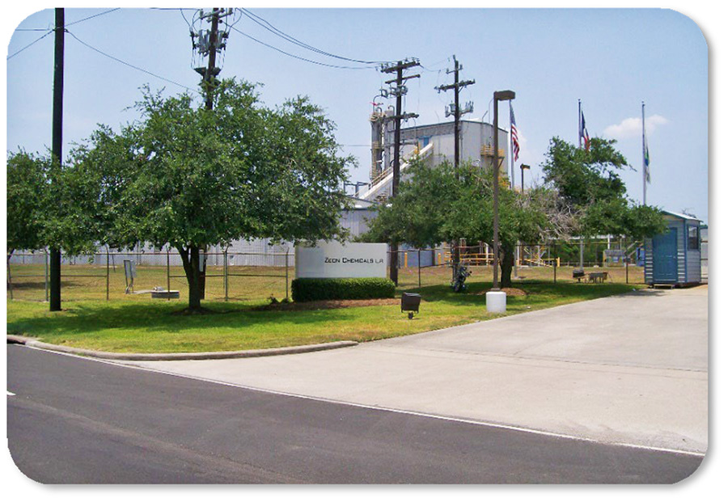 | ZEON will increase Zetpol® production capacity by 25 percent at US Plant in Pasadena, Texas, by 2025  Copyright: ZEON Chemicals L.P.  Download: https://www.ahlendorf-news.com/media/news/images/zeon-chemicals-zetpol-plant-texas-h.jpg

COMPANY PROFILE – ZEON Corporation is the world leader in specialty elastomers, polymers, and specialty chemicals. ZEON is one of the top producers of polymers in the world, operating a global network of plants in Asia and North America, and research and development laboratories in Japan, USA, China, and Singapore. With more than 70 years in business and consolidated sales of ca. US$ 2.5 billion, ZEON has both the experience and the expertise in C4 and C5 chemistry to offer a wide range of world class products. ZEON employs over 4,300 people worldwide, with global headquarters in Tokyo and regional sales offices all over Europe, America and Asia. “We realize the importance of having a close partnership with (potential) customers worldwide. Therefore, our resources in sales and technical service always put great effort into technical cooperation to bring positive momentum to our customers. Then, together we will find the optimum solution,” Hubert Thimm, ZEON Europe Commercial Director explained.

While ZEON is continuously settled in the traditional global elastomer business (60% of total business), the specialty material business has been progressively built up and has been growing significantly. ZEON specialty materials will provide material solutions for the future world in terms of sustainable energy sources, electromobility, digitalisation and media, as well as modern lifestyle and health care.

Media Contact
Tatiana Kromhout
ZEON Europe GmbH
E-Mail: tatiana.kromhout@zeon.eu
Phone: +49-211-5267-0
Hansaallee 249
DE-40549 Düsseldorf

