Change in the Management at Distec

Ulrich Ermel Succeeds Bernhard Staller

Germering (Germany) March 15, 2023 – Distec GmbH, one of the leading German specialists for industrial TFT flat panel displays, embedded products and system solutions, announced that there has been a change in the management: Bernhard Staller is going into his well-deserved retirement. On March 1, 2023, Ulrich Ermel has taken over the position of Managing Director. As an electrical engineer (FH) and graduate engineer, he has extensive management and leadership skills as well as expertise in the areas of power supplies and embedded systems. He brings a broad range of competencies from distribution and production to the development of complete solutions.

Mr. Matthias Keller will continue to serve on the management board, so that a dual leadership will still be available for business partners and customers. “I am very pleased to welcome Ulrich Ermel as my new Managing Director colleague,” explained Matthias Keller. "His many years of experience and broad knowledge of our industry will undoubtedly make a valuable contribution to our continued success. With his dual role as both Managing Director of Distec GmbH and COO of our parent company, FORTEC Elektronik AG, he will help to implement our common strategy and vision and further drive the growth of our company. We wish Mr. Staller all the best for his future and thank him sincerely for his many years of commitment.”

Ulrich Ermel welcomes the new tasks: “I am pleased to be able to accompany the transformation together with all Distec colleagues and to continuously support our customers with technological excellence and a lot of passion. With innovative products, such as the ‘unbreakable’ BLO-Line and new ways in product marketing (Distec Short Films), we are optimistic about the year 2023. The positive, collegial, and pragmatic company culture at Fortec AG and all affiliated companies inspires me. Another highlight for me is the close collaboration with my colleague Matthias Keller, with whom I can finally work personally after years in the industry.”

Words: 333

Images

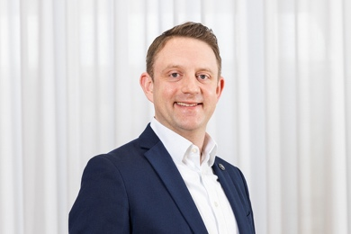 | Image 1: Ulrich Ermel succeeds Bernhard Staller on the management board of Distec  Copyright: Distec  Download: https://www.ahlendorf-news.com/media/news/images/Distec-Ermel-Ulrich-H.jpg
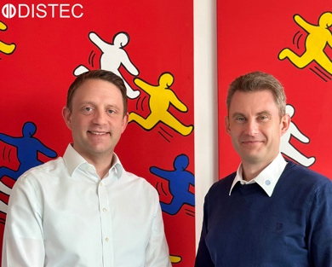 | Image 2: Distec continues to rely on dual leadership with Ulrich Ermel and Matthias Keller (from left) for best customer service  Copyright: Distec  Download: https://www.ahlendorf-news.com/media/news/images/Distec-Ermel-Keller-H.jpg

About Distec

Distec GmbH is a FORTEC Group company, a globally active and recognized specialist in the field of display technology and embedded computing for projects from all industries. The company, headquartered in Germering near Munich and with a factory in Hörselberg-Hainich near Eisenach, develops, manufactures, and markets innovative solutions and a wide range of components, TFT displays, embedded boards, systems and services. The innovative solutions from assemblies and kits to OEM end products are based on hardware and software developed by Distec in its own design center in Germering. Distec's range of services includes customer-specific developments and adaptations, product refinements such as VacuBond® optical bonding and the assembly of monitor systems, as well as the manufacture of finished products. A wide range of touch screens and the internal touch competence center enable individual touch solutions even for difficult environmental conditions. In addition, Distec GmbH can draw on the goods, services and know-how of the extensive FORTEC high-tech company network. Further information can be found at https://www.distec.de/

The products of Distec GmbH are available at:
Europe: Distec GmbH, Germering, https://www.distec.de/
UK and Benelux: Display Technology, Huntingdon, https://www.displaytechnology.co.uk/
North America: Apollo Display Technologies, Ronkonkoma NY, http://www.apollodisplays.com/
Turkey and Middle East: DATA DISPLAY BİLİŞİM TEKNOLOJİLERİ LTD ŞTi., Istanbul

Distec GmbH
Augsburger Straße 2b
82110 Germering
Germany
T +49 89 894363 0
F +49 89 894363 131
E distribution|at|distec.de
W www.distec.de

A company of FORTEC Group

Press contact:
Mandy Ahlendorf
ahlendorf communication
T +49 89 41109402
E ma@ahlendorf-communication.com

