First Automotive Gigabit Ethernet Switch with Optical Ports

KDPOF Switch Evaluation Board EVB9351-AUT-SW-NXP Implements NXP SJA1110 SoCs and 1000BASE-RH Optical Ports for Connected Driving

Madrid (Spain) September 22, 2022 – KDPOF, leading supplier for gigabit connectivity over fiber optics, introduces the first automotive Ethernet switch EVB9351-AUT-SW-NXP with five 1000BASE-RH optical ports, each comprised of KDPOF’s KD9351 FOT and KD1053 PHY IC. “We very much appreciate the support from NXP® Semiconductors, a world leader in secure connectivity solutions for embedded applications, in the development of our new switch evaluation board,” stated Carlos Pardo, CEO and Co-founder of KDPOF. “The core of the high-speed switch platform is the new NXP SJA1110 SoC.”

Günter Sporer, Director of Marketing, Systems and Applications of Automotive Ethernet Solutions at NXP Semiconductors, added, “With the SJA1110, NXP Semiconductors provides a family of four pin-compatible and software-compatible automotive Ethernet switch SoC. Thus, we offer a scalable solution for automotive applications.” KDPOF’s new evaluation board supports carmakers and suppliers in delivering high-speed connectivity essential for the progress of autonomous vehicles.

Scalable Automotive Ethernet Switch for High-speed Networks

The EVB9351-AUT-SW-NXP automotive Ethernet switch board has two SJA1110 switches from NXP on board. This part integrates an ARM Cortex-M7 @200MHz processor for autonomous and secure operation: 512 kB integrated SRAM as Instruction Tightly Coupled Memory (ITCM) and 256 kB integrated SRAM as Data Tightly Coupled Memory (DTCM). It further contains a double-precision floating-point unit and a memory protection unit. Boot time is less than 100 ms with a 512 kB firmware with authentication. The switch has selectable I/O voltages (1.8V, 2.5V and 3.3V) to aid in design flexibility. It provides a small footprint of 14 mm by 14 mm (LFBGA256) and a package with 0.8 mm pitch. It is automotive AEC-Q100 qualified, compliant with ISO 26262, and ASIL-B. 2.5 Gb/s operation is supported for two SGMII ports. The board has five optical 1000/100BASE-RH ports, 12 100BASE-T1 ports, and one NXP SABRE expansion connector.

EMC-safe and Reliable: 1000BASE-RH Optical Ports with KDPOF Chipset

With the KD9351 optical interface, KDPOF complements the proven KD1053 digital interface IC, thus providing a full optical port for in-vehicle gigabit connectivity. The assembly of the FOT and the IC is simplified, and the connector offers snap-fit without soldering. The devices form a complete automotive 1000BASE-RHC physical layer. Constructing the transimpedance amplifier, photodiode, LED driver, and LED as one single device significantly lowers costs.

Optical Ethernet connectivity perfectly solves the challenges and electrical interference in vehicles thanks to its electromagnetic compatibility, reliability, and low cost. Applications include safe Ethernet backbones, smart antenna modules, and sensor connections for ADAS and audio/video.

Words: 431

More information
https://www.kdpof.com/wp-content/uploads/2022/08/KDPOF-br030-EVB9351-AUT-SW-NXP-Eval-Board-Brochure-1v1.pdf

Keywords: KDPOF, IEEE, fiber optics, KD1053, KD9351, gigabit, automotive, automotive Ethernet, in-vehicle connectivity, automotive network, ADAS, autonomous vehicle, automated driving, connected vehicles, EMC, EMC-safe, photonics, NXP Semiconductors, EVB9351-AUT-SW-NXP, 1000BASE-RHC, NXP SJA1110

Images

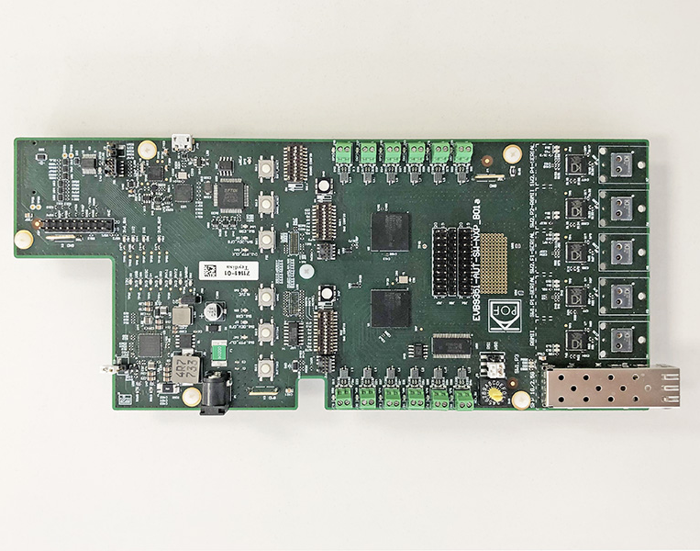 |  | Image 1: KDPOF implements NXP SJA1110 SoC in new automotive Ethernet switch for high-speed connectivity  Copyright: KDPOF  Download: https://www.ahlendorf-news.com/media/news/images/KDPOF-evb9351-aut-sw-nxp-H.jpg
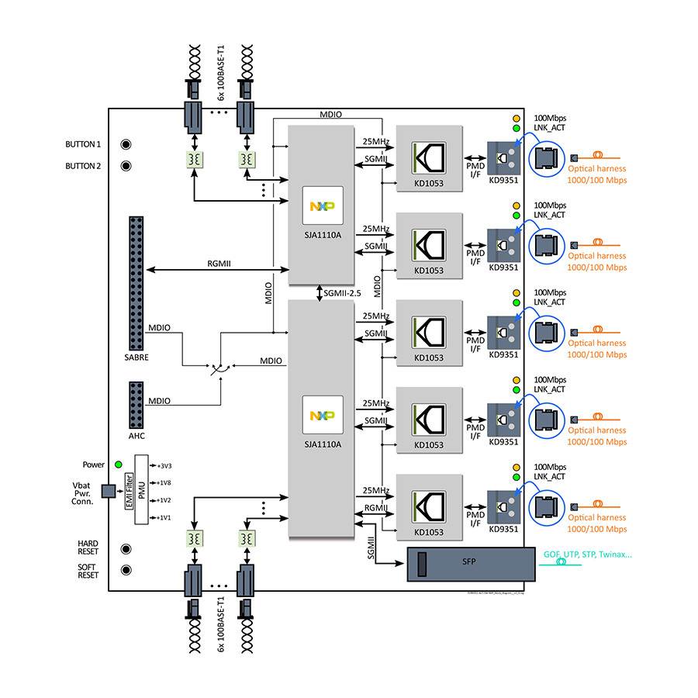 |  | Image 2: Block diagram of KDPOF’s new automotive Ethernet switch EVB9351-AUT-SW-NXP for gigabit Ethernet  Copyright: KDPOF  Download: https://www.ahlendorf-news.com/media/news/images/KDPOF-evb9351-aut-sw-nxp-block-diagram-H.jpg
Image 3: Günter Sporer, Director Marketing, Systems and Applications of Automotive Ethernet Solutions at NXP Semiconductors

Copyright: NXP Semiconductors
Download: https://www.ahlendorf-news.com/media/news/images/nxp-guenter-sporer-H.jpg
Image 4: Carlos Pardo is CEO and Co-founder of KDPOF

Copyright: KDPOF
Download: https://www.ahlendorf-news.com/media/news/images/KDPOF-Pardo-Carlos-4-H.jpg

About KDPOF

Fabless semiconductor supplier KDPOF provides innovative high-speed optical networking for harsh environments. KDPOF made gigabit communications overstep-index plastic optical fiber (SI-POF) a reality for automotive. Founded in 2010 in Madrid, Spain, KDPOF offers its cost-effective technology as a fully qualified automotive-grade ASSP. KDPOF’s technology makes use of innovative digital adaptive algorithms to maximize the receiver’s sensitivity. This supports high-yield and reliable optoelectronics production in low-cost bulk CMOS deep submicron nodes, delivering carmakers low risk, low cost, and short time-to-market. More information is available at www.kdpof.com.

KDPOF Knowledge Development for POF, S.L.
Ronda de Poniente 14, 2ª Planta
28760 Tres Cantos, Spain
E pr@kdpof.com
T +34 918043387

Media Contact:
Mandy Ahlendorf
ahlendorf communication
E ma@ahlendorf-communication.com
T +49 89 41109402

