Efficient System-in-Package "MSMP1" from ARIES Embedded

New OSM-compatible SiP Integrates ST Microelectronics' STM32MP1 MPU with Arm CortexA7/M4 for Industrial and IoT Applications

Fuerstenfeldbruck, Germany, July 19, 2022 - The new System-in-Package (SiP) "MSMP1" from ARIES Embedded, specialist in embedded services and products, is based on the STM32MP1 CPU family from ST Microelectronics with powerful single or dual Arm CortexA7 cores (up to 800 MHz), combined with a CortexM4 core (up to 209 MHz). The SiP is compliant with SGET's OSM (Open Standard Module) standard. "Almost all functions of the CPU are available on the small board measuring only 30 by 45 mm," explained Andreas Widder, Managing Director of ARIES Embedded. "The 476 contacts of the SiP module allow the CPU to be used transparently in demanding applications. It features low power consumption, small form factor, and competitive cost." Thus, the MSMP1 is ideally suited for applications in IoT, medical technology, and industrial systems.

Versatile with Low Power Consumption

The MSMP1 modules are scalable in terms of performance and memory expansion and can therefore be individually adapted to many project requirements. The system-in-packages support 512 MB to 4 GB DDR3L RAM and 4 to 64 GB eMMC NAND Flash. The numerous interfaces include 10/100/1000 Mbit Ethernet, USB2.0 host/OTG, 2x CAN, UART, I²C, SPI, ADC/DAC, as well as a parallel display interface and camera input. The modules are available in the commercial temperature range, with 0 °C to +70 °C, as well as in the industrial temperature range, with -40 °C to +85 °C.

Samples of the MSMP1 SiP will be available from the third quarter of 2022. ARIES Embedded will start series production in the fourth quarter of 2022.

Words: 278

More information:
https://www.aries-embedded.com/system-on-module/cpu/stmp157-stmicro-cortexa7-msmp1-osm-ethernet-can

Keywords: Aries Embedded, Embedded System, FPGA, MSMP1, System-in-Package, System-on-Module, Industrial, ST Microelectronics, STM32MP1, OSM, Open Standard Module, IoT, medical technology

Images

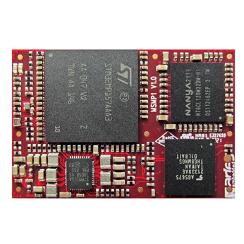 | Image 1: Efficient, OSM-compatible MSMP1 SiP with Arm CortexA7/M4 from Aries Embedded for IoT and industrial systems  Copyright: ARIES Embedded GmbH  Download: https://www.ahlendorf-news.com/media/news/images/aries-embedded-msmp1-sip-stmicroelectronics-1-H.jpg
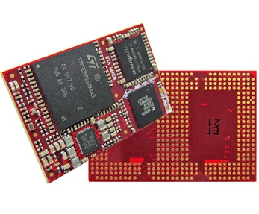 | Image 2: The versatile MSMP1 SiP from Aries Embedded is based on the STM32MP1 MPU from ST Microelectronics  Copyright: ARIES Embedded GmbH  Download: https://www.ahlendorf-news.com/media/news/images/aries-embedded-msmp1-sip-stmicroelectronics-2-H.jpg
Image 3: Andreas Widder is Managing Director of ARIES Embedded GmbH

Copyright: ARIES Embedded GmbH
Download: http://www.ahlendorf-news.com/media/news/images/aries-embedded-Andreas-Widder-H.jpg

About ARIES Embedded

ARIES Embedded provides hardware and software development and standard products for industrial and agricultural sectors. The 2001 founded embedded specialist headquartered in Fuerstenfeldbruck, Germany, focuses on FPGA technology and open source software. The portfolio comprises of modular systems for flexible and fast use in functional prototypes, pilot series and mass production. On customer request, ARIES Embedded individually customizes standard products in accordance with project requirements. Further information is available at www.aries-embedded.com.

ARIES Embedded GmbH
Schöngeisinger Str. 84
DE-82256 Fürstenfeldbruck
Fon: +49 8141 36 367 0
Fax: +49 8141 36 367 67
www.aries-embedded.com
info@aries-embedded.de

Media Contact
Mandy Ahlendorf
ahlendorf communication
ma@ahlendorf-communication.com
+49 89 41109402

