System Solution for Optical Communications in Vehicles

KDPOF Presents Reliable and Cost-efficient Multi-gigabit Connectivity System at ELIV VDI Congress

Madrid (Spain) September 14, 2021 – Together with several industry leaders, KDPOF – leading supplier for gigabit connectivity over fiber optics – is working on an optical automotive multi-gigabit system that will fulfill the needs of future connected and automated vehicles. Instead of various port components, the new solution provides a single, complete package. “As the auto industry approaches the 50 Gb/s*m speed-length threshold, the move from copper to optical physical data transmission media is becoming mandatory,” stated Carlos Pardo, CEO and Co-founder of KDPOF. “Optical is the engineering-wise path for higher data rates.” The new connector systems are very small, lightweight and extremely inexpensive compared to the previous ones. With the comprehensive EVK9351AUT evaluation kit, automotive manufacturers and suppliers can already test the new configuration at 1 Gbit/s today. KDPOF thus supports easy project entry into optical gigabit connectivity for a secure Ethernet backbone and ADAS sensor connections in vehicles.

KDPOF will present their optical Multi-gigabit Ethernet Connectivity System at ELIV (Electronics In Vehicles) International VDI Congress on October 20 to 21, 2021 at stand 38 in Bonn, Germany, and online.

Off-the-shelf System Solution for In-vehicle Networking

The key advantages of the optical solution, among others, are superior Electromagnetic Compatibility (EMC) thanks to the inherent galvanic isolation, low weight, and low cost. The optical cables are absolutely reliable and at least as flexible as copper cables in the same bandwidth range. They allow fast, dynamic and tight bending as well as immersion in dark liquids. In addition, optical connectivity guarantees easy engineering for seamless implementation. The ecosystem already exists since the system leverages well-proven technologies, such as VCSELs (Vertical-cavity surface-emitting laser), multimode fibers and photodiodes already developed for the data centers industry. The technology will be scalable in order to enable even higher data rates, such as 50 and 100 Gb/s, in the future. Standardization processes are ongoing with IEEE 802.3 Automotive Ethernet and ISO PWI 24581 in progress. The robust and reliable system solution provided by KDPOF and industry leaders thus offers the future-proven path to high speeds.
Reliable, Robust and Cost-efficient

The proposed Multi-gigabit system supports Energy-Efficient Ethernet (EEE) tailored for automotive applications and wakes up in less than 100 ms. The target BER is better than 10⁻¹² with ambient operating temp from -40ºC up to 105ºC (AEC-Q100 grade 2) in harsh automotive environments. High reliability (15 years operation, less than 10 FIT) and outstanding EMC compliance are also fulfilled. The technology in development is based on advanced digital signal processing, using high-speed DAC and ADC to implement all needed algorithms such as equalization or pre-coding. A new optical automotive IVN communication standard IEEE 802.3cz is currently in the task force phase and is targeting data rates of 2.5, 5, 10, 25, and 50 Gb/s. It is supported by several industry-leading companies. First engineering samples of the new automotive, single-chip, fully integrated Fiber Optic Transceiver package solution for 10 Gb/s will be available from KDPOF in fall 2022.

Words: 507

Keywords: KDPOF, fiber optics, multi-gigabit, automotive, automotive Ethernet, in-vehicle connectivity, automotive network, ADAS, autonomous vehicle, autonomous driving, EMC, photonics, ELIV

Images
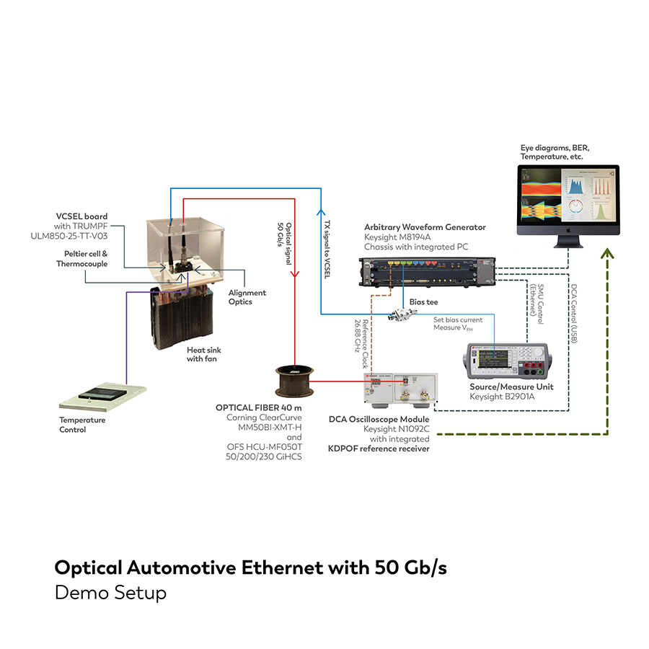 |  | Image 1: Demo setup of the optical multi-gigabit system solution from KDPOF for in-vehicle connectivity  Copyright: KDPOF  Download: https://www.ahlendorf-news.com/media/news/images/KDPOF-auto-optical-multi-gigabit-system-H.jpg
Image 2: Carlos Pardo is CEO and Co-founder of KDPOF

Copyright: KDPOF
Download: https://www.ahlendorf-news.com/media/news/images/KDPOF-Carlos-Pardo-H.jpg

About KDPOF

Fabless semiconductor supplier KDPOF provides innovative high-speed optical networking for harsh environments. Making gigabit communications over fiber optics a reality, KDPOF technology supplies 1 Gb/s POF links for automotive, industrial, and home networks. Founded in 2010 in Madrid, Spain, KDPOF offers their cost-effective technology as either ASSP or IP (Intellectual Property) to be integrated in SoCs (System-on-Chips). The adaptive and efficient system works with a wide range of optoelectronics and low-cost large core optical fibers, thus delivering carmakers low risk, low cost and short time-to-market. More information is available at www.kdpof.com.

KDPOF Knowledge Development for POF, S.L.
Ronda de Poniente 14, 2ª Planta
28760 Tres Cantos, Spain
E pr@kdpof.com
T +34 918043387

Media Contact:
Mandy Ahlendorf
ahlendorf communication
E ma@ahlendorf-communication.com
T +49 89 41109402

