M100PFS SoM with Microchip's PolarFire SoC FPGA Goes into Series Production

ARIES Embedded Expands System-on-Modules Product Range with First RISC-V Based FPGA Module

Fuerstenfeldbruck, Germany, June 8, 2021 – ARIES Embedded, a specialist in embedded services and products, has started volume production of the powerful and efficient M100PFS System-on-Module (SoM). The platform is based on Microchip's PolarFire® system-on-chip (SoC) FPGA family, the high-performance 64-bit RISC-V quad-core processor subsystem with low-power FPGA technology. "The M100PFS is now fully available and we have already supplied the first customer projects with it," explained Andreas Widder, Managing Director of ARIES Embedded. "In addition to general availability, we have added significantly to the range of functions. The module features its IP reference design, a customized zero-stage bootloader, U-Boot as a generic bootloader, Linux with Yocto support, and Hart Software Services (HSS)." The embedded board impresses with its low power consumption, very good efficiency and high system security in a variety of different use cases. It is ideal for applications such as safety-related systems and artificial intelligence, where a high-performance, secure and energy-efficient computer architecture is to be combined with an FPGA. Its wide range includes applications such as smart embedded vision, industrial automation with robotics, telecommunications and industrial Internet of Things (IIOT).

Reliable Operation Thanks to Hart Software Services

The Polarfire RISC-V quad-core SoC has an additional core for control and monitoring tasks. A range of special services run on this E51 monitor core with Hart Software Services, offering many options for configuration and ensuring reliability in operation. For example, the RISC-V cores can be used with different operating systems or bare-metal. This makes it possible to implement advanced real-time or security requirements for an embedded system.

In addition to the SoM, ARIES Embedded offers the M100PFSEVP evaluation board for an easy and fast project start into FPGA SoC design. The baseboard can be flexibly extended via Pmod connectors or an HSMC port and can thus be used for the fast realization of prototyping.
Words: 328

The M100PFS is available in the online shop:
https://shop.aries-embedded.de/system-on-module/m/m100pfs/

Technical information:
https://www.aries-embedded.com/polarfire-soc-fpga-microsemi-m100pfs-som-mpfs025t-pcie-serdes

Images

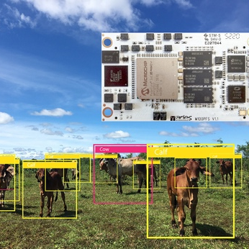 | Image 1: M100PFS SoM from ARIES Embedded with Microchip’s PolarFire SoC FPGA goes into series production  Copyright: Shutterstock/ARIES Embedded GmbH  Download: https://www.ahlendorf-news.com/media/news/images/aries-embedded-M100PFS-polarfire-fpga-microchip-ki-H.jpg
Image 2: Andreas Widder is Managing Director of ARIES Embedded GmbH

Copyright: ARIES Embedded GmbH
Download: http://www.ahlendorf-news.com/media/news/images/aries-embedded-Andreas-Widder-H.jpg

About ARIES Embedded

ARIES Embedded provides hardware and software development and standard products for industrial and agricultural sectors. The 2001 founded embedded specialist headquartered in Fuerstenfeldbruck, Germany, focuses on FPGA technology and open source software. The portfolio comprises of modular systems for flexible and fast use in functional prototypes, pilot series and mass production. On customer request, ARIES Embedded individually customizes standard products in accordance with project requirements. Further information is available at www.aries-embedded.com.

ARIES Embedded GmbH
Schöngeisinger Str. 84
DE-82256 Fürstenfeldbruck
Fon: +49 8141 36 367 0
Fax: +49 8141 36 367 67
www.aries-embedded.com
info@aries-embedded.de

Media Contact
Mandy Ahlendorf
ahlendorf communication
ma@ahlendorf-communication.com
+49 89 41109402

