New KD9351 FOT Reduces Cost for Gigabit Connectivity

KDPOF Provides Efficient Optical Technology for Safe Backbone and ADAS Sensor Links in Vehicles

Madrid (Spain) March 10, 2021 – The new integrated KD9351 Fiber Optic Transceiver (FOT) from KDPOF – leading supplier for gigabit connectivity over fiber optics – further reduces costs for optical in-vehicle networks at 1 Gb/s. Incorporating the transmit and receive optoelectronics into one single component, the KD9351 is an optical transceiver for 100 Mb/s up to 1 Gb/s with a small footprint. “Compared to STP (shielded twisted pair of copper wires), the combination of the new KD9351 FOT with the continuing KD1053 IC cuts the cost for 1 Gb/s by 30 percent,” explained Carlos Pardo, CEO and Co-founder of KDPOF. “The new integrated device provides enhanced efficiency and flexibility. It thus paves the way to optical multi-gigabit Ethernet in the vehicle.” Applications for the new KD9351, with competitive pricing for EMC critical or galvanic isolated critical links, include safe Ethernet backbones and sensor links for advanced driver assist systems (ADAS).

KD9351: the KDPOF FOT

KDPOF significantly lowers costs for the new KD9351 by constructing the transimpedance amplifier, photodiode, LED driver, and LED as one single device. Additional benefits are a shorter supply chain and no test duplication with the final test at the Tier1. Furthermore, the assembly of the FOT and the existing KD1053 IC is simplified and the connector offers snap-fit without soldering. The KD9351 reuses low-cost MEMs encapsulation and allows SMD reflow assembly with 8 by 7 mm LGA components. It is fully shielded against electromagnetic radiation. Fiber connection is done with a very simple plastic connector placed on top. The temperature range, from -40 °C to +105 °C, conforms with harsh automotive environmental requirements. The FOT withstands motor conditions with a vibration class of V2. Additionally, the device endures water without sealing. EMC performance is excellent even with the ECU shield case removed, as shielding is integrated into the PCB component. Optics implement Tx and Rx lenses. Samples are already available.

Words: 334

Images

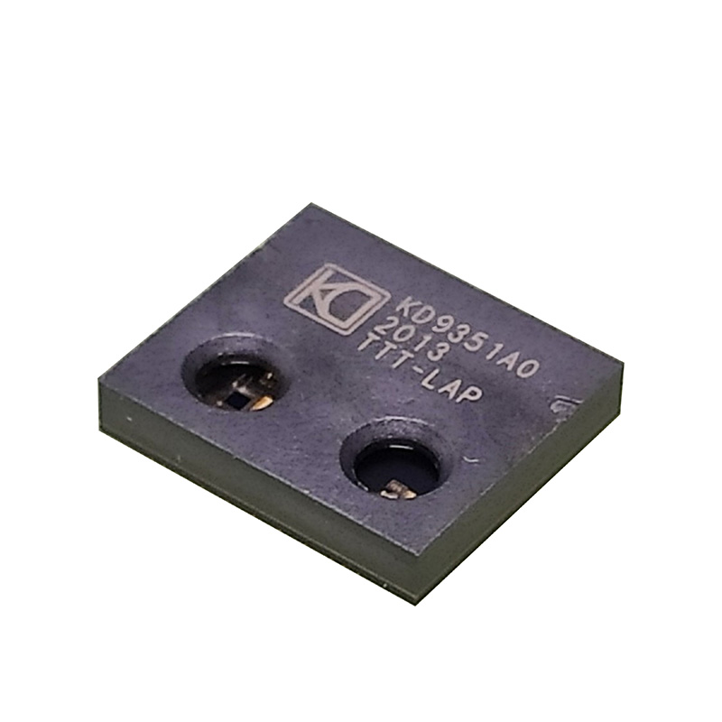 |  | Image 1: KDPOF presents new integrated KD9351 FOT for automotive gigabit connectivity  Copyright: KDPOF  Download: https://www.ahlendorf-news.com/media/news/images/KDPOF-KD9351-automotive-fiber-optics-H.jpg
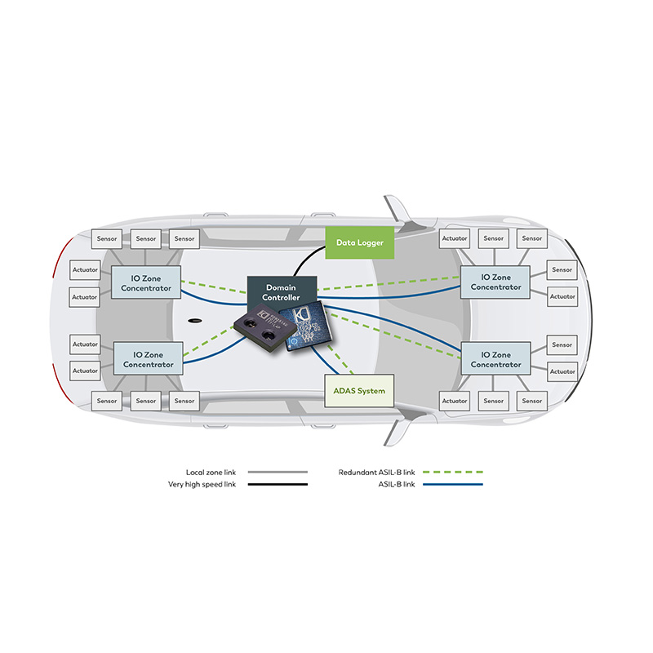 |  | Image 2: Efficient optical technology from KDPOF for safe backbone and ADAS sensor links in vehicles  Copyright: KDPOF  Download: https://www.ahlendorf-news.com/media/news/images/KDPOF-KD9351-safe-backbone-H.jpg
Image 3: Carlos Pardo is CEO and Co-Founder of KDPOF

Copyright: KDPOF
Download: https://www.ahlendorf-news.com/media/news/images/KDPOF-Carlos-Pardo-H.jpg

About KDPOF

Fabless semiconductor supplier KDPOF provides innovative high-speed optical networking for harsh environments. Making gigabit communications over fiber optics a reality, KDPOF technology supplies 1 Gb/s POF links for automotive, industrial, and home networks. Founded in 2010 in Madrid, Spain, KDPOF offers their cost-effective technology as either ASSP or IP (Intellectual Property) to be integrated in SoCs (System-on-Chips). The adaptive and efficient system works with a wide range of optoelectronics and low-cost large core optical fibers, thus delivering carmakers low risk, low cost and short time-to-market. More information is available at www.kdpof.com.

KDPOF Knowledge Development for POF, S.L.
Ronda de Poniente 14, 2ª Planta
28760 Tres Cantos, Spain
E pr@kdpof.com
T +34 918043387

Media Contact:
Mandy Ahlendorf
ahlendorf communication
E ma@ahlendorf-communication.com
T +49 89 41109402

