Distec presents a robust, sunlight readable 7-inch TFT display from Ortustech

Distec's IF420-00 adapter board extends the COM70H7M24ULC with interfaces and drivers for optimum control

Germering (Germany) June 27, 2019 – Distec GmbH - leading German specialist for TFT flat screens and system solutions for industrial and multimedia applications – now offers Ortustech's transflective 7-inch TFT display COM70H7M24ULC with perfect readability even in very difficult environmental conditions. "The New Blanview technology ensures a particularly high-contrast and color-true display and very low power consumption at the same time - even in direct sunlight and without an active backlight," explained Leonhard Spiegl, Product Manager Components at Distec GmbH. For easy control with extended interfaces and backlight driver, Distec developed the adapter board IF420-00 and can also supply a completely assembled display-interface unit on request. The rugged display has a wide operating temperature range and is specified for vibration of up to 6.8 G. It withstands extremely harsh environmental conditions and is ideal for mobile applications in industry, agriculture and construction.

Durable in harsh environments

The compact display with WVGA resolution (800x480) features a brightness of 400cd/m². The long-life LED backlight promises a lifetime of 100,000 hours. This corresponds to a period of more than 11 years of continuous operation before reaching half the original brightness. With an operating temperature range of -30 to +85 °C, the COM70H7M24ULC withstands frost and heat easily and is the perfect solution for mobile devices and outdoor use. An optional glass cover protects the display surface from scratches, prevents the ingress of dirt and allows for easy cleaning with conventional cleaning agents. "Upon request, we can optically bond a corresponding protective glass and/or a touchscreen on the display, using our own VacuBond optical bonding process," added Leonhard Spiegl. "The optical gel we use for bonding stabilizes the unit, absorbs shocks, and increases its robustness even more."

IF420-00 adapter board improves connectivity

The display is controlled via flex cable with an LVDS interface. To simplify the direct connection to a graphics card, Distec provides the adapter board IF420-00 for easy control: It converts the interface of the display to a standard LVDS and backlight interface and also features an on-board driver for the LED backlight. The IF420-00 is suitable for the COM70H7M24ULC and also for Ortustech's connection-compatible 5-inch display COM50H5N01ULC. On request, Distec supplies the IF420-00 already mounted on the back of the TFT display as a complete solution.

Words: 399

Images

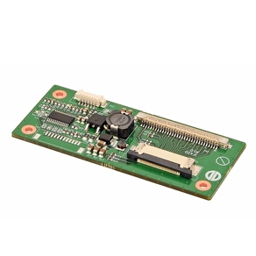 | Image 1: Distec’s adapter board IF420-00 improves the connectivity of Ortustech’s TFT displays COM70H7M24ULC  Copyright: Distec GmbH  Download: http://www.ahlendorf-news.com/media/news/images/distec-if420-gender-board-H.jpg
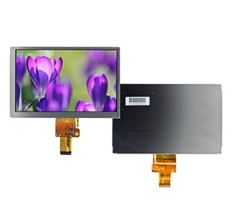 | Image 2: Robust, sunlight readable 7-inch TFT display COM70H7M24ULC by Ortustech featuring New-Blanview technology  Copyright: Distec GmbH  Download: http://www.ahlendorf-news.com/media/news/images/distec-ortustech-COM70H7M24ULC-H.jpg
Image 3: Leonhard Spiegl is Product Manager Components at Distec GmbH

Copyright: Distec GmbH
Download: http://www.ahlendorf-news.com/media/news/images/Distec- Spiegl-Leonhard-2-H.jpg

About Distec

Distec is a FORTEC Group member and a worldwide operating specialist for TFT flat screen and system solutions for industrial, multimedia and digital signage applications. Located in Germering near Munich in Germany, the company designs, produces and sells innovative solutions and a full range of components, displays and services. Distec supplies innovative Green IT solutions based on their hardware platforms and their own software to control the TFTs of its partners AUO Innolux, Kyocera, Mitsubishi, Ortustech, SGD and Tianma as well as selected panels from other manufacturers. These system solutions - from assemblies and kits up to finished OEM products - are developed in their own R&D centers in Germering (Germany) and Ronkonkoma (NY/USA). The range of services includes customized developments and adaptations, product finishing and assembly of monitoring systems as well as the production of finished products and a complete after-sales service with RMA, repair and technical support. Moreover, Distec has access to products, services and the expertise of the large FORTEC high-tech company network, which makes a perfect complement to the product portfolio. More information can be found on the homepage: https://www.distec.de/en

Distec’s products are available at:
Europe: Distec GmbH, Germering, https://www.distec.de
UK and Benelux: Display Technology, Huntingdon, https://www.displaytechnology.co.uk
North America: Apollo Display Technologies, Ronkonkoma NY, http://www.apollodisplays.com/
Turkey and Middle East: DATA DISPLAY BİLİŞİM TEKNOLOJİLERİ LTD ŞTi., Istanbul

Distec GmbH
Augsburger Straße 2b
82110 Germering
Germany
T +49 89 89 43 63 0
F +49 89 89 43 63 131
E distribution|at|distec.de
W www.distec.de

A FORTEC Group Member

Media Contact:
Mandy Ahlendorf
T +49 89 41109402
E ma@ahlendorf-communication.com

