SpiderSoM Opens Broad Access to FPGA Technology

ARIES Embedded Complements Industrial MX10-SoM by Entry-Level System-on-Module for Expanded User Community

Fuerstenfeldbruck, Germany, 21 May 2019 – With the FPGA-based System-on-Module (SoM) "SpiderSoM", ARIES Embedded, specialist for embedded services and products, presents a basic module for getting started with FPGA programming. Similar to its industrial upgrade MX10, the SpiderSoM is a programmable, non-volatile board based on the Intel® MAX®10 FPGAs. "With the SpiderSoM, we are consciously lowering the entry threshold, opening design work with FPGAs to all development groups," explained Andreas Widder, Managing Director of ARIES Embedded. "This enables us to reach out to users outside of industrial tasks and to expand the community for the professional information exchange on high-performance FPGA technology. The entry-level SoM offers complete FPGA functionality, including support for various softcore CPUs.

Prompt Project Start and Open Design Concept

ARIES Embedded provides the evaluation board SpiderBase for a fast design start with both SpiderSoM and MX10-SoM. The cost-effective and extremely flexible platform allows users to set up a running system according to the required specifications in a very short time. The board contains a large prototype area. With the SpiderBoard, ARIES Embedded supports the free and open design concept: All resources such as design and Gerber files as well as the source code are available under open source licenses, KiCAD design data under CERN OHL v1.2.

Introduction to FPGA Programming

The SpiderSoM supports Intel MAX®10 FPGAs from 10M02SC to 10M16SA in U169 package with single power supply. The board, with dimensions of 70 by 35 mm, offers GPIO pins and optional 4 Mbit SPI NOR flash, 8 Mbit SDRAM and RTC with battery backup and lithium ion (Li-Ion) or lithium polymer (Li-Po) charger.

The Wiki on spiderboard.org helps users through the first steps with the new platform. Step-by-step instructions like 'Getting Started' or an example for the implementation of a RISC-V softcore CPU are available.
MX10-SoM for Industrial Use

For professional electronics designs in industrial applications, ARIES Embedded offers the MX10-SoM for Intel MAX®10-FPGAs from 10M04DC to 10M50DA in the F256 package. To compare to the SpiderSoM, the MX10-SoM also features 128/256/512 Mbit DDR3 DRAM (for 10M 16/25/40/50 FPGAs), a programmable clock generator and PLL with optional external reference input. The 178 FPGA GPIO pins include 13 LVDS transmitters and 54 receivers. The FPGA's input and output voltages can be configured via programmable, high-efficient power management ICs (PMICs).

Words: 399

Images

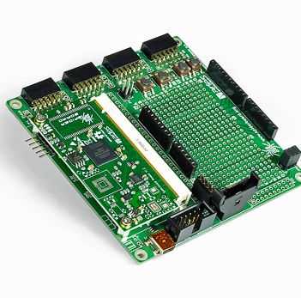 | Image 1: SpiderBase and SpiderSoM from ARIES Embedded with Intel® MAX®10 FPGA expand user community for FPGA technology.  Copyright: ARIES Embedded GmbH  Download: http://www.ahlendorf-news.com/media/news/images/aries-embedded-SpiderSoM-SpiderBase-Intel-FPGA-H.jpg
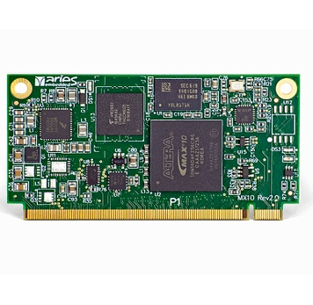 | Image 2: For professional electronics designs in industrial applications, ARIES Embedded offers the MX10-SoM for Intel MAX®10-FPGAs.  Copyright: ARIES Embedded GmbH  Download: http://www.ahlendorf-news.com/media/news/images/aries-embedded-MX10-SoM-Intel-FPGA-H.jpg
Image 3: Andreas Widder is Managing Director of ARIES Embedded GmbH

Copyright: ARIES Embedded GmbH
Download: http://www.ahlendorf-news.com/media/news/images/aries-embedded-Andreas-Widder-H.jpg

About ARIES Embedded
ARIES Embedded provides hardware and software development and standard products for industrial and agricultural sectors. The 2001 founded embedded specialist headquartered in Fuerstenfeldbruck, Germany, focuses on FPGA technology and open source software. The portfolio comprises of modular systems for flexible and fast use in functional prototypes, pilot series and mass production. On customer request, ARIES Embedded individually customizes standard products in accordance with project requirements. Further information is available at www.aries-embedded.com.

ARIES Embedded GmbH
Schöngeisinger Str. 84
DE-82256 Fürstenfeldbruck
Fon: +49 8141 36 367 0
Fax: +49 8141 36 367 67
www.aries-embedded.com
info@aries-embedded.de

Media Contact
Mandy Ahlendorf
ahlendorf communication
ma@ahlendorf-communication.com
+49 89 41109402

