Boosting Customer Quality of Experience through Optical Connectivity

KDPOF Delivers Plastic Optical Fibers to Home Networks - Cost-efficient, Easy to Install, Robust

Madrid, Spain, June 28, 2018 – KDPOF – leading supplier for gigabit transceivers over POF (Plastic Optical Fiber) – introduces a Plastic Optical Fiber backbone inside the home: in combination with Wi-Fi access points, POF provides end users with maximum performance for both wireless and wired connectivity throughout the house. POF reuses any existing conduits in the home, making these cables invisible. "ISPs and Telecom operators are offering higher and higher access speeds while users at home are locally connecting more and more devices to the internet," explained Carlos Pardo, CEO and Co-Founder of KDPOF. "The paradox is that while access speeds have increased, customer satisfaction rates drop if home networks cannot keep up."

POF Enhances Quality of Experience

This is particularly worrisome because Quality of Experience has become a very important differentiator for broadband service providers. Customers expect to experience the speeds they are paying for. If these speeds are lower than expected, they will be disappointed and the Quality of Experience will be affected. KDPOF has been working closely with Telefónica in a trial to test the benefits of POF. KDPOF’s technology helps to provide subscribers with very high connectivity speeds all around the home, allowing users to enjoy high-quality video streaming such as 4K IPTV, and supporting services such as online gaming with the lowest latency. According to the results of the trial, Quality of Experience can increase dramatically, leading to a surge in customer loyalty. Sara Martin-Sanz Albendea, Project Manager with Telefónica and responsible for the project known within Telefónica as 'Plastic Optical Fiber in the House': "KDPOF offers a great solution for improving customer satisfaction. Quality of Experience is a key success factor for Telefónica."

Reliable High-speed Connectivity for Homes

ISPs and Telecom Operators have been investigating various potential solutions. No-New-Wires technologies such as Wireless Mesh or Powerline do not offer a clear alternative. These solutions have performance problems in houses with brick and mortar walls, or they are degraded since they depend too much on the existing and often old, low-quality cabling. New-cable solutions such as Ethernet Cabling require new ducts to be created, which is difficult for customers to accept. Plastic Optical Fiber, on the other hand, is cost-efficient, easy to install, and robust. By working with KDPOF, operators can offer their clients low latency, fast download speeds, and reliable connectivity for video.

Words: 409

For the video with more information, please see https://youtu.be/UoeC9cg-jMI

Images

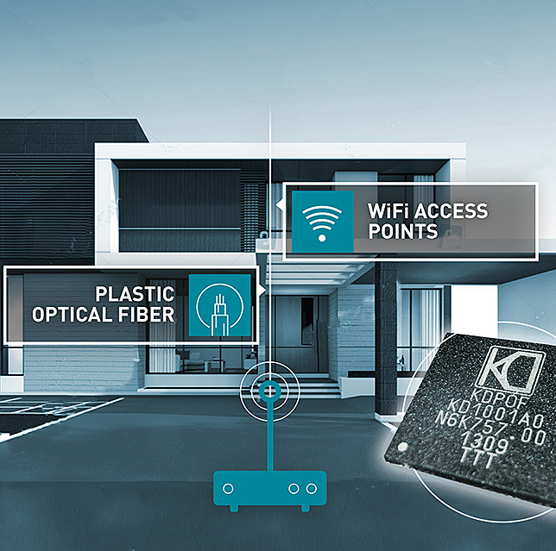 |  | Image 1: KDPOF speeds up home networking with POF backbone for higher Quality of Experience  Copyright: KDPOF  Download: http://www.ahlendorf-news.com/media/news/images/KDPOF-POF-Telefonica-KD1001-home-soho-H.jpg
Image 2: Carlos Pardo is CEO and Co-Founder of KDPOF

Copyright: KDPOF
Download: http://www.ahlendorf-news.com/media/news/images/KDPOF-Carlos-Pardo-H.jpg

About KDPOF

Fabless semiconductor supplier KDPOF provides innovative gigabit and long-reach communications over Plastic Optical Fiber (POF). Making gigabit communication over POF a reality, KDPOF technology supplies 1 Gbps POF links for automotive, industrial, and home networks. Founded in 2010 in Madrid, Spain, KDPOF offers their technology as either ASSP or IP (Intellectual Property) to be integrated in SoCs (System-on-Chips). The adaptive and efficient system works with a wide range of optoelectronics and low-cost large core optical fibers, thus delivering carmakers low risks, costs and short time-to-market. More information is available at www.kdpof.com.

KDPOF Knowledge Development for POF, S.L.
Ronda de Poniente 14, 2ª Planta
28760 Tres Cantos
Spain
E support@kdpof.com
T +34 918043387

Media Contact:
Mandy Ahlendorf
ahlendorf communication
E ma@ahlendorf-communication.com
T +49 8151 9739098

