Data Logging: Intelligently and Efficiently

Ethernet Live Monitor by RUETZ SYSTEM SOLUTIONS Optimizes Error Analysis in Real Time

Munich (Germany) February 21, 2018 – RUETZ SYSTEM SOLUTIONS – experts in automotive data communications – present the new Ethernet Live Monitor (ELM) for intelligent and efficient error analysis of data transports in automotive networks. "The enormous amount of audio and video data (A/V) challenges data monitoring systems, with the result that loggers do not monitor permanently and thus only analyze audible and visible errors," explained Wolfgang Malek, General Manager and Co-Founder of RUETZ SYSTEM SOLUTIONS. "With the Ethernet Live Monitor, we close the gap and do complete, live monitoring of Ethernet traffic." Once the Ethernet Live Monitor detects an irregularity it triggers the data logger, initiating the recording of relevant data. It is available in two versions. The Ethernet Live Monitor 1000BASE-T uses an external Ethernet TAP (Terminal Access Point) that timestamps the hardware-related packages. The Ethernet Live Monitor 100BASE-T1 has this TAP already implemented. For configuration and display, test engineers simply require a PC. The Live Monitor can easily be integrated in existing test systems or test vehicles for in-system diagnosis of AVB/TSN.

Live Testing with Intelligent Data Management

The Ethernet Live Monitor detects errors in the live stream by means of the various complex test algorithms. It then triggers the data logger in order to record the relevant data. It automatically identifies irregularities and non-audible and non-visible errors. In addition, it sends an error description to the data logger and stores it with the filed traces for subsequent, effective error analysis. During the following analysis, test engineers already know what issue and time stamp to look for. In addition, data loggers have to provide less storage space. The Ethernet Live Monitor scans data frames directly on the bus without influencing the original network. Thus, RUETZ SYSTEM SOLUTIONS provides intelligent data management: only truly relevant data is recorded and errors are reported to the corresponding log file. It contains more than 40 complex test algorithms for IEEE 802.1AS, 1722/1722a, which can be expanded by costumer-specific test algorithms. In addition, it offers low power input, a robust body, passive cooling, and EMC-proof aluminum housing. Consequently, it perfectly qualifies for vehicle testing. A separate offline analysis tool is also available.

Words: 375

Images

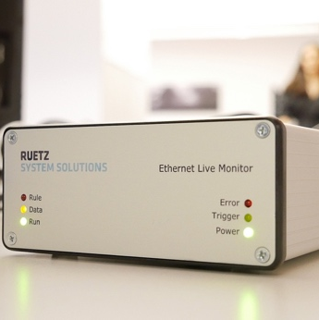
Image 1: The Ethernet Live Monitor identifies the according errors in the live stream and triggers the data logger.

Copyright: RUETZ SYSTEM SOLUTIONS
Download: http://www.ruetz-system-solutions.com/uploads/RUETZ-SYSTEM-SOLUTIONS-Ethernet-Live-Monitor-H.jpg

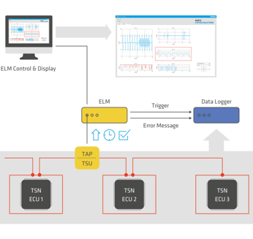
Image 2: The Ethernet Live Monitor scans data frames on the bus directly without influence on the original network.

Copyright: RUETZ SYSTEM SOLUTIONS
Download: http://www.ruetz-system-solutions.com/uploads/RUETZ-SYSTEM-SOLUTIONS-Ethernet-Live-Monitor-graphic-H.jpg
Image 3: Wolfgang Malek is General Manager and Co-Founder of RUETZ SYSTEM SOLUTIONS

Copyright: RUETZ SYSTEM SOLUTIONS
Download: http://www.ruetz-system-solutions.com/uploads/RUETZ-SYSTEM-SOLUTIONS-Wolfgang-Malek.jpg
RUETZ SYSTEM SOLUTIONS
With comprehensive expertise in data communication for automotive electronic systems, Ruetz System Solutions provides full service to carmakers and suppliers for a smooth and timely production start (SOP). The technology partner based in Munich offers engineering services for system specification and integration, compliance tests, technology assessment, and training. Part of the test laboratory solutions are test systems and platforms. With broad competency in data bus systems for all in-car data transmission standards such as, amongst others, AVB, Bluetooth, CAN, Automotive Ethernet, FlexRay, LIN, MOST, USB, and WLAN are supported competently and reliably by the general contractor. More information is available at www.ruetz-system-solutions.com.

RUETZ SYSTEM SOLUTIONS GmbH
Oskar-Schlemmer-Strasse 13
80807 Munich, Germany

Media Contact:
ahlendorf communication
Mandy Ahlendorf
T +49 8151 9739098
E ma@ahlendorf-communication.com

