KDPOF Equips Electric Cars with Optical Connectivity

Presentation of Automotive Gigabit Ethernet POF at Automotive Ethernet Congress

Madrid, Spain, January 29, 2018 – KDPOF – leading supplier for automotive gigabit connectivity over POF (Plastic Optical Fiber) – provide their innovative Automotive Gigabit Ethernet POF (GEPOF) for electric and autonomous driving to perfectly solve the electrical challenges and interferences of new powertrain architectures. "We are happy to announce that several car makers and Tier-1 suppliers have adopted our optical technology for electrical powertrains and autonomous vehicles," stated Carlos Pardo, CEO and Co-Founder of KDPOF. "Electromagnetic noise is a major issue in any electrical power train, both in full electrical or hybrid architectures. It affects the operation of the electronic circuits within the car and countermeasures have to be taken at early stages of the design." Consequently, due to the presence of hazardous high voltage (above 25 Vac or 60 Vdc), galvanic isolation is necessary between the domains of a battery management system and also between the primary and secondary systems of both ac-dc and dc-dc. Optical connections with POF provide the optimal means to achieve galvanic isolation while realizing data communications between the domains at the same time. KDPOF will present their GEPOF technology at Automotive Ethernet Congress on January 30 and 31, 2018 in Munich, Germany.

Optical Connectivity for Electric and Hybrid Vehicles

The control of all the subsystems involved in the electrical powertrain requires a communication bus that transports the control, actuation and sensor signals among the different components in all domains. The communication bus has to be immune to the electromagnetic noise and, at the same time, comply with the mechanical, temperature, and weight constraints of the overall vehicle. 1000BASE-RH, the Ethernet specification for a Gigabit capable, POF-based communication protocol, is ideal for the new architectures, as it provides a natural galvanic isolation between communicating modules and a radiation free harness. Moreover, it can operate at 100 Mbps for most current needs while also supporting future needs at 1 Gbps.

KDPOF recently announced the sampling of the KD1053, the first automotive grade Gigabit Ethernet POF transceiver. The KD1053 complies with the new IEEE standard amendment Std 802.3bv™ for Gigabit Ethernet over POF. It fully meets the requirements of carmakers by providing high connectivity with a flexible digital host interface, low latency, low jitter, and low linking time.

Words: 386

Images

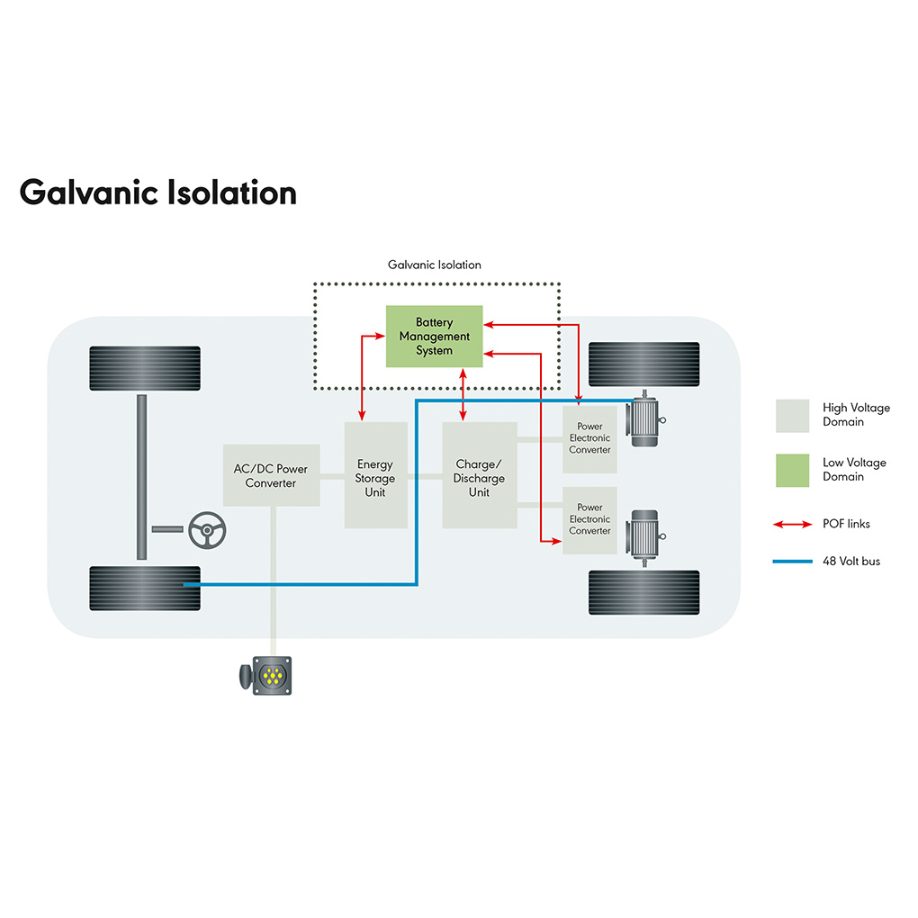 |  | Image 1: KDPOF delivers optical connectivity for powertrains in electric and hybrid vehicles.  Copyright: KDPOF  Download: http://www.ahlendorf-news.com/media/news/images/KDPOF-electric-vehicle-galvanic-isolation-H.jpg
Image 2: Carlos Pardo is CEO and Co-Founder of KDPOF

Copyright: KDPOF
Download: http://www.ahlendorf-news.com/media/news/images/KDPOF-Carlos-Pardo-H.jpg

About KDPOF

Fabless semiconductor supplier KDPOF provides innovative gigabit and long-reach communications over Plastic Optical Fiber (POF). Making gigabit communication over POF a reality, KDPOF technology supplies 1 Gbps POF links for automotive, industrial, and home networks. Founded in 2010 in Madrid, Spain, KDPOF offers their technology as either ASSP or IP (Intellectual Property) to be integrated in SoCs (System-on-Chips). The adaptive and efficient system works with a wide range of optoelectronics and low-cost large core optical fibers, thus delivering carmakers low risks, costs and short time-to-market. More information is available at www.kdpof.com.

KDPOF Knowledge Development for POF, S.L.
Ronda de Poniente 14, 2ª Planta
28760 Tres Cantos
Spain
E support@kdpof.com
T +34 918043387

Media Contact:
Mandy Ahlendorf
ahlendorf communication
E ma@ahlendorf-communication.com
T +49 8151 9739098

