IOP Tester for Ethernet ECUs

RUETZ SYSTEM SOLUTIONS Tests ECUs for Interoperability

Munich (Germany) March 9, 2016 – RUETZ SYSTEM SOLUTIONS – experts for automotive data communications - provides an interoperability test platform for Automotive Ethernet. This IOP tester operates within the framework of compliance tests for Automotive Ethernet. The test platform constitutes a component of the test set-up for Open Alliance Layer 1 interoperability tests for ECUs. The IOP tester allows the verification of ECUs for interoperability with other ECUs for Layer 1, based on (100BASE-T1 / OABR). It offers an open application programming interface (API) and, so, is easy to integrate into existing test systems. Users can create their own tests and test sequences. Measurements of link-up time, signal quality and cable diagnosis belong within the scope of testing.

Compliance for Ethernet ECUs

The IOP tester is a component of the compliance verification process at RUETZ SYSTEM SOLUTIONS. The standardized test methods for Automotive Ethernet combine the new automotive standards with existing reliable and stable systems. Therefore, for component and ECU verification, the compliance verification process provides the necessary system and simplifies the introduction to this technology for new carmakers and suppliers.

Words: 192

Images

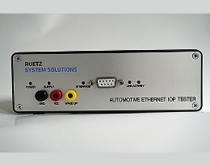
Picture 1: IOP tester from RUETZ SYSTEM SOLUTIONS tests ECUs for interoperability
Copyright: RUETZ SYSTEM SOLUTIONS
Download: http://www.ruetz-system-solutions.com/uploads/RUETZ-SYSTEM-SOLUTIONS-Automotive-Ethernet-IOP-Tester-H.jpg

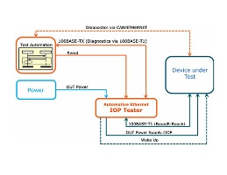
Picture 2: Test structure for Automotive Ethernet interoperability
Copyright: RUETZ SYSTEM SOLUTIONS
Download: http://www.ruetz-system-solutions.com/uploads/RUETZ-SYSTEM-SOLUTIONS-Automotive-Ethernet-Interoperability-Test-Setup-H.jpg

Picture 3: Wolfgang Malek is General Manager and Co-Founder of RUETZ SYSTEM SOLUTIONS.
Copyright: RUETZ SYSTEM SOLUTIONS
Download: http://www.ruetz-system-solutions.com/uploads/RUETZ-SYSTEM-SOLUTIONS-Wolfgang-Malek.jpg

RUETZ SYSTEM SOLUTIONS

With comprehensive expertise in data communication for automotive electronic systems, Ruetz System Solutions provides full service to carmakers and suppliers for a smooth and timely production start (SOP). The technology partner based in Munich offers engineering services for system specification and integration, Test Laboratories as a Service, compliance tests, technology assessment and training. Part of the test laboratory solutions are test systems and platforms. With broad competency in data bus systems for all in-car data transmission standards such as, amongst others, AVB, Bluetooth, CAN, Automotive Ethernet, FlexRay, LIN, MOST, USB and WLAN are supported competently and reliably by the general contractor. More information is available at www.ruetz-system-solutions.com.

RUETZ SYSTEM SOLUTIONS GmbH
Walter-Gropius-Strasse 17
81543 Munich, Germany

Media Contact:
Mandy Ahlendorf
T +49 8151 9739098
E ma|at|ahlendorf-communication.com

